Daily Items to Pack for School
It is essential that your child arrive at school with everything he needs to keep him safe in all potential weather conditions for that day. In the worst-case scenario, he won’t be allowed to stay at school with inadequate clothing if it’s deemed a safety concern by your child’s teacher. We also want kids to be comfortable enough to have fun and enjoy themselves!
The good news is that our maritime climate creates a lot of mild, predictable weather. Our foremost concern is staying dry in all the wet weather we get in the Pacific Northwest.
Planning is a crucial step for any outdoor excursion. We encourage you to involve your child in this process to learn the habit of being prepared. Checking the weather may become a favorite activity.
Expect all clothing to get filthy, especially boots, pants, and gloves/mittens. On wet days, you will likely want towels to protect the surfaces in your car, and you may want a clean, dry set of clothing ready for your child either in your home’s entry or to change into in the car if your child won’t be going home immediately (include dry shoes).
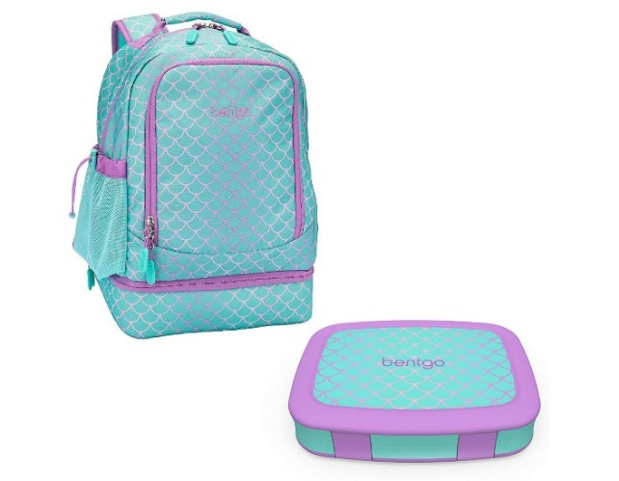
Daily essentials
Please label all of your child’s belongings and clothing with their name! We will do our best to avoid mix-ups, but we cannot be held responsible for lost, stolen or damaged items
- Backpack. Check that the backpack fits your child, so they can take responsibility for carrying their own things, and check that your child’s essentials will fit inside—many children’s backpacks are simply too small to hold their outdoor clothing.
- Water bottle. Your child’s water bottle needs to close tightly enough to prevent leaks when upside down in his bag. As many hikers have learned the hard way: all the warm, dry clothing in the world becomes useless when your water bottle soaks it inside your bag. Please do not fill water bottles with juice. Your child may bring a thermos with a warm beverage if desired.
- Bandana.
- A small snack that includes protein. The best snack choices don’t create a lot of mess if spilled; your child will most often be sitting on the ground during snack time. Unwrapping tricky wrappers before packing those items provides your child with self-sufficiency. Include some protein to keep your child’s blood sugar level even so their brain is at its best! Think nut butter pouches, apple slices, bananas, pepperoni sticks, cheese, crackers, carrot sticks, veggies, trail mix, etc. Please do not include candy or junk food. Some parents like bento boxes that have a tray a child can set on her lap as a makeshift table. Because of allergies, we discourage sharing and trading snack items with other students.
- Personal items. Personal-size hand sanitizer (Teachers also bring hand sanitizer and wipes for the class). Chapstick, especially on cold and windy days.
- Waterproof sack or plastic bag to contain any wet or soiled clothing (consider placing extra clothing inside to help ensure it stays dry!).
- Extra socks. Please ALWAYS pack an extra pair of socks for your child. Seal them in a ziplock bag.
- Optional: Field notebook and writing utensils, packed in a sturdy ziplock or other waterproof bag. We recommend choosing a notebook with blank, unlined pages to accommodate drawing and sketching. A hard cover helps to keep pages flat and create a surface for writing. We suggest sending 2-4 colored pencils as the writing utensils so your child can both write and draw. A whole box of colored pencils is likely too many to keep track of. A hard pencil case is handy for protecting pencils. Teachers bring pencil sharpeners.
- Please do not bring any toys from home.

