EDUCATIONAL PHILOSOPHY
How should we prioritize children’s time at the youngest ages? This is the central question that guides the educational philosophy of Chickadee Hollow Preschool. Experts recognize that early childhood is a sensitive time for the kinds of learning kids do through open-ended play, being in nature, and interacting with people. Balancing these activities is more art than science.
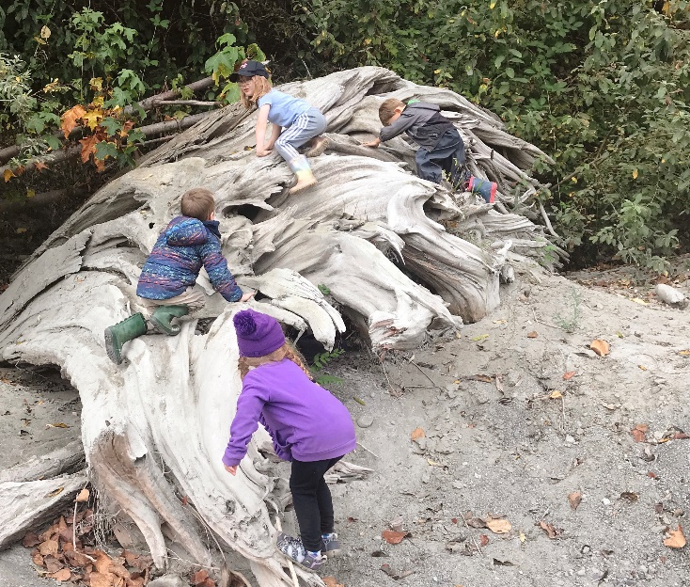
Developmentalist Jean Piaget said, “Play is the work of children.” Montessori programs take this concept seriously, advising adults to avoid interrupting the child deeply immersed in play, just as adults appreciate not being interrupted when concentrating on work. One of the first revolutionary notions to arise from developmental science was that play, observed in the young of numerous species across the planet, has important functions that translate into real skills. How best to facilitate play-based learning for kids?
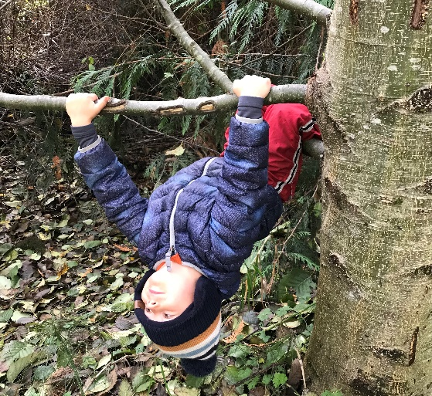
Gross motor play is what kids do with their whole bodies (in contrast to fine motor activities that they do by holding pencils and other small instruments to accomplish delicate tasks). Gross motor play is fantastic exercise. It strengthens muscles, develops coordination, exercises the heart and lungs, and improves balance. Play on natural materials like logs and uneven ground surfaces, rather than built environments like plastic playground materials and sidewalks, is especially effective at shaping a strong and agile body. Using the large muscles for running and jumping keeps kids warm. On cold days, we find ways to encourage a lot of movement. Many children who show signs of attention deficits have greater needs for physical movement in their day to nourish their brains. All kids feel better when they get enough movement. It’s also helpful for falling asleep easily and getting quality sleep, which has a major impact on children’s learning. Movement is a cornerstone of a healthy life and a feature of every day at Chickadee Hollow Preschool.
We are protective of the time that our students get for free play, meaning we will not schedule their whole day with structured activities. Likewise, as educators, we take advantage of opportunities to educate and make connections in the direction of lifelong learning. Our balance of free play and structured learning evolves in collaboration with the students and their interests. We aim to scaffold children’s natural curiosity into the types of intentional learning that optimize the opportunities presented by the developmental window of early childhood.
We always want to make sure that a child’s first experience with school is full of joy and that they like to be there as much as possible. For many children, sitting and listening is not what they want to be doing (for many others it’s what they like best—all kids are different!). One way that we ensure our teaching time doesn’t over-draw from kids’ play time and that it fits our students’ needs by implementing an emergent “curriculum”—one custom-designed for the class week by week.
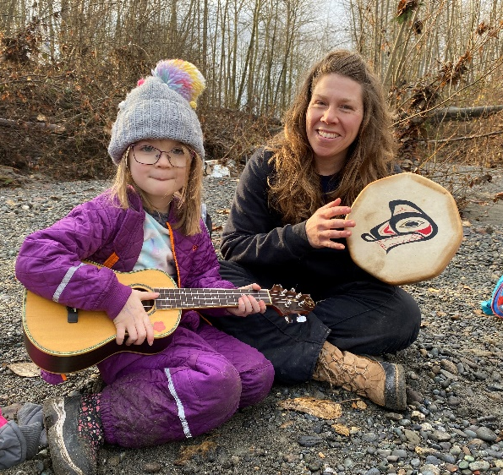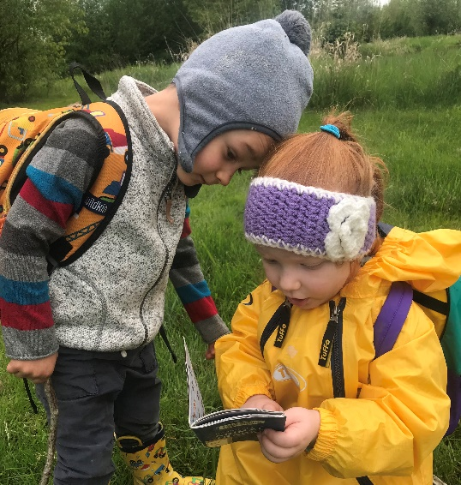
Our emergent activity plan is designed to be developmentally appropriate for pre-school age children. That means we focus on foundational skills: We cultivate a school environment that builds foundations for learning and life. The most important goal we have is to foster curiosity.
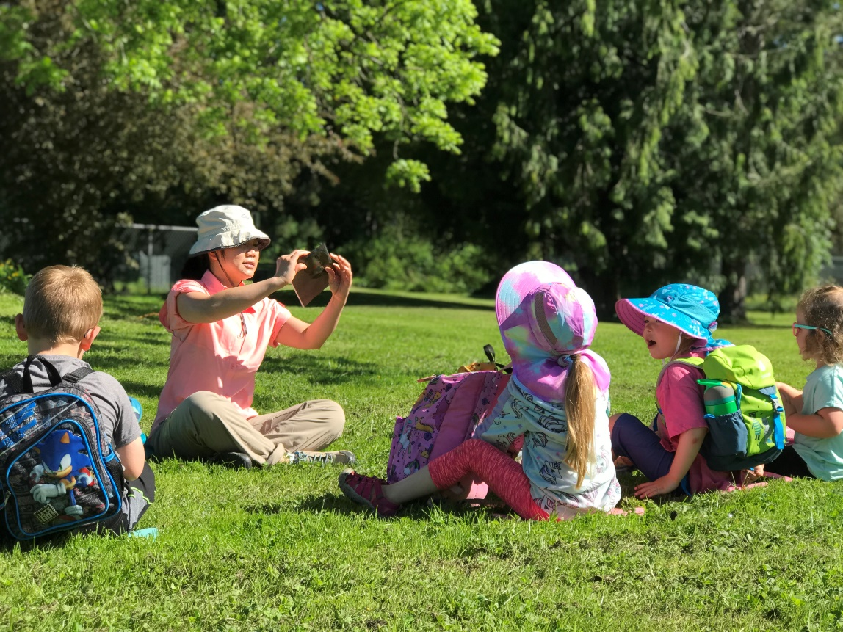
Books and Stories
We believe in the importance of taking the time to read books together every single day. Storytime has always been a central component of our circle time, whether reading books, intentionally practicing pre-literacy skills, or telling stories with story boards, finger puppets, or other storytelling objects. We find ways to engage each child during story time, and we offer access to our library of books, rotating according to the current theme, during free time.
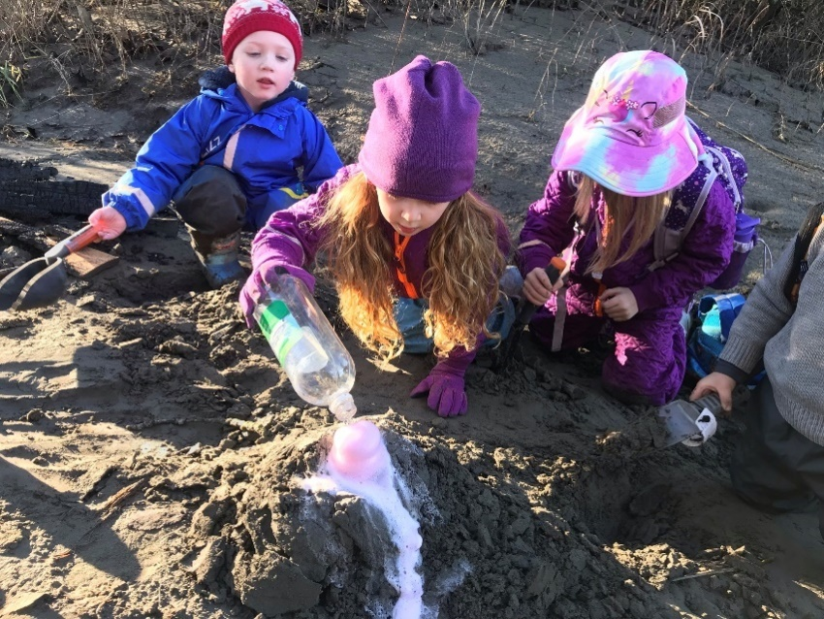
Science
Science is a natural topic for outdoor education. We have found that our emerging themes are often organized around science concepts because these are foundational to many of the questions that arise in a nature setting. We love to answer questions with questions, or by setting up experiments. This is an approach to teaching that teaches reasoning, self-directed learning, and curiosity, and helps develop a scientific framework for studying the world.

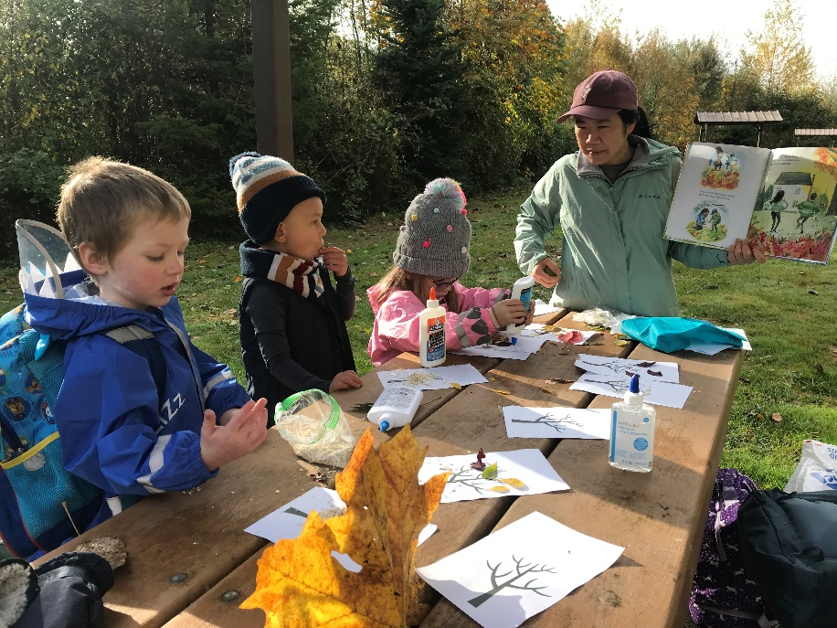
Art
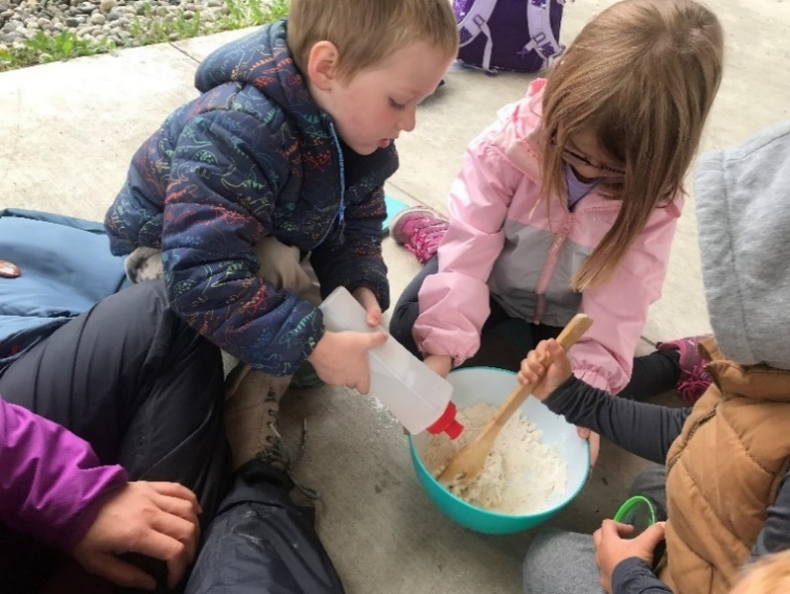
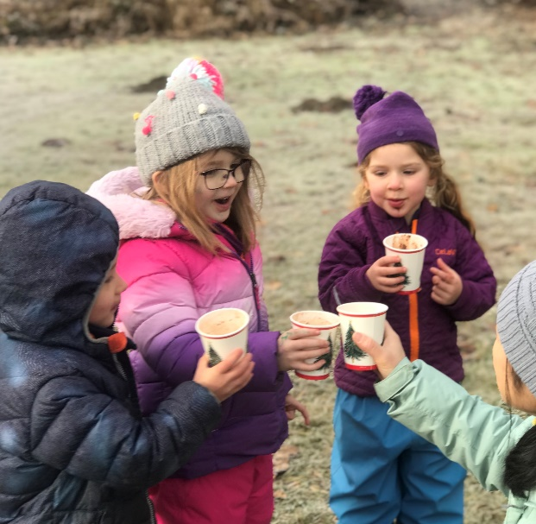
Art is playful. Art also supports other concepts being taught, and teaches functional skills like pencil grip, scissors skills, using paintbrushes, glue, dough, and other mediums. It takes good fine motor skills to put a googly eye right where you want it! These activities are great for preschool kids because they simply take practice (lots and lots of practice) to master them, and then the sky is the limit on kids’ creativity. Clear some space on your fridge, shelves, and walls. You are going to have lots of art to showcase in the coming months!

Social Skills and Practical Life Skills
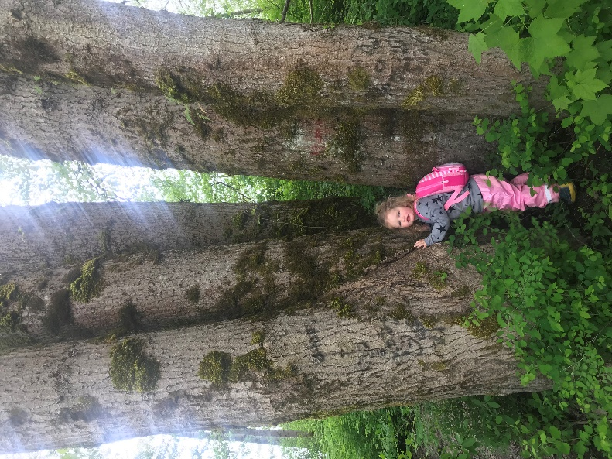
We occasionally teach functional skills and social skills in a structured way, but much more often, learning opportunities arise during play. These include sharing, taking turns, resolving conflict, empathy, self-regulation, manners, respect, perseverance, friendship, and bravery.
We support kids as they gain independence in mastering functional skills like tying shoes, putting on gloves, zipping, snapping, and buttoning clothing, and manipulating objects for self-feeding and self-care.
Early childhood can be thought of as an awakening. The budding mind just needs the right conditions to bloom.

