Dressing your child for the outdoors
The first priority is choosing clothing that will keep your child warm and dry. If your child has a pair of sound rain boots and a waterproof rain coat and rain pants, you’re most of the way there. Specialty outdoor clothing is likely unnecessary. Before you start shopping, “shop” your child’s existing wardrobe to identify pieces that fit the following criteria; you may be surprised how little you need to add. Tip: If most of your child’s clothing is cotton, start stocking up on fleece layers wherever you find them—and fleece pants and sweaters can be found at many garage sales and thrift stores.
Your child needs to bring three layers of clothing to school: A base layer, mid layer, and outerwear. They also need to bring appropriate protection for hands, feet, and head. What does this mean?
Base layer—Shirt and pants
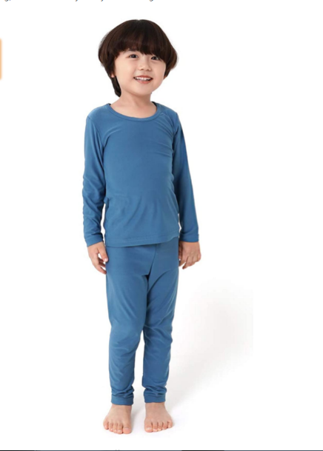
The base layer is worn closest to the skin. You don’t need to purchase special thermal underwear to serve as a base layer. By far the most important thing about the base layer is simply that it’s not made from cotton—cotton will not wick moisture away from the body and whether from the elements or from sweat, cotton becomes damp and chills the body.
Wool makes a wonderfully warm and breathable base layer, but it’s expensive, and you’ll want to look for thin, stretchy wool pieces (usually marketed specifically as base layers, or possibly as pajamas) for this layer (By all means, snag chunky wool sweaters for your child’s mid layers!).
The best option for most families will be synthetic fabrics: polyester, nylon, etc. You’ll want to be able to fit your child’s other layers over his base layer, so look for thinner and closer-fitting synthetic clothes with plenty of stretch, like thin fleece or athletic apparel like yoga pants, long-sleeved sports tees, or lighter sweats. Costco sells Kirkland brand thermals (make sure that you don’t purchase cotton) and Amazon has inexpensive options for synthetic thermal underwear:
https://www.amazon.com/dp/B01HEZMR6I/ref=twister_B0776BNXZS?_encoding=UTF8&psc=1

Mid Layers: Sweater/s or a coat

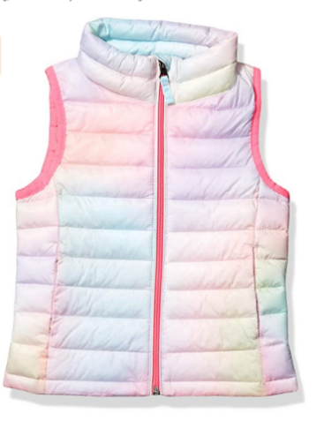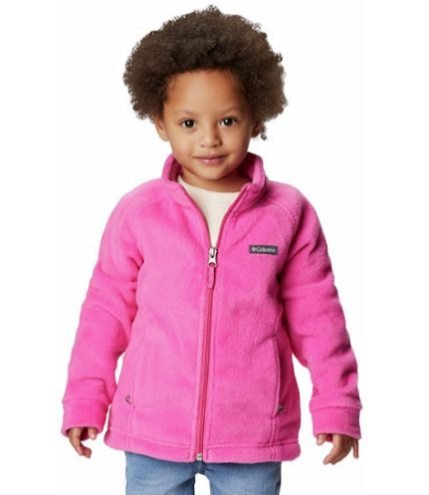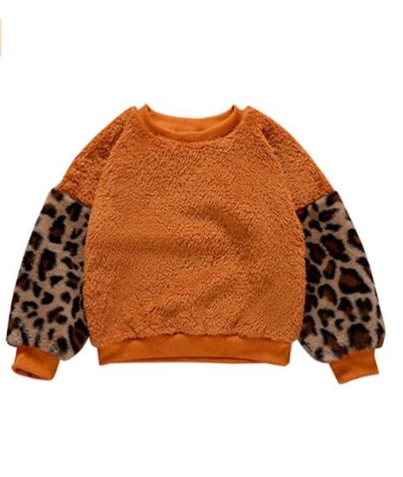

The mid-layer is about adding warmth. Thicker is not necessarily better. Trapping heat is the name of the game, and layers trap heat most efficiently; two thin shirts layered together may trap more heat than one sweater. Additionally: the more layers, the more versatility. The least versatile choice is a big puffy polyester-filled coat with a built-in waterproof outer layer. If these layers at least zip apart, your child has more options when, for instance, it’s rainy but she’s running around and feeling warm. My preference for spring quarter is to avoid polyester-filled coats altogether and just layer a couple of sweaters/fleeces. As well as offering better temperature control, layering traps more heat and keeps kids warm with less bulk. Wool and fleece are the best material choices for mid layers, but as long as you avoid cotton, just about anything will do.
How many mid layers do you need? As a rule of thumb, dress your child for comfort based on the conditions and have at least one extra mid layer packed in her backpack. On very cold days this could mean several mid layers (and/or double base layers).

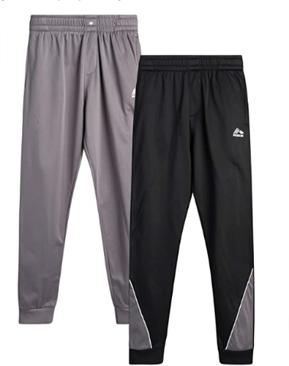

You’ll want to own pants for your child in a mid-layer weight, but two layers of pants per day, including rain pants, is typically the maximum for spring weather in this climate. Choose either a base layer, like leggings, or a mid-layer, like thick fleece or polyester sweatpants, to wear underneath rain pants (or have rain pants packed in your child’s backpack). Avoid jeans!

Outer layer – Rain coat and rain pants
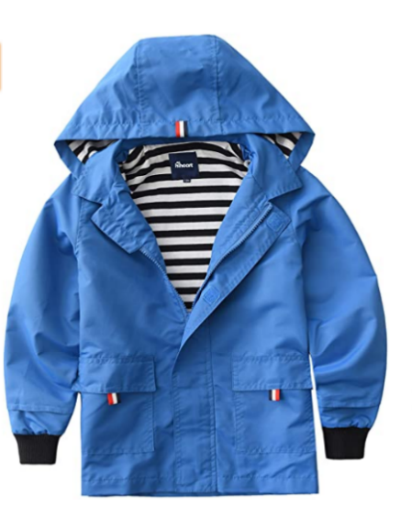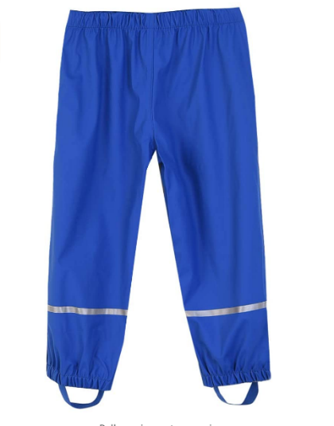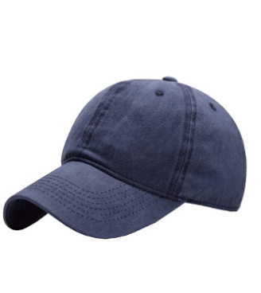

Your child is required to have rain pants to attend Chickadee Hollow Preschool. They must also have a rain jacket. Don’t confuse windproof material with waterproof. Again, for your primary pieces it’s better to avoid waterproof clothes with built-in insulation like all-in-one winter coats and snow pants. Instead, look for thin waterproof outer layers.

You’re welcome to choose rain suits that combine coat and pants, like Muddy Buddy brand suits. Have your child practice taking the suit on and off for bathroom breaks.

My preference is the brighter colors, the better—keep kids visible!

A rain jacket with a stiff hood will help keep the rain out of your child’s eyes, or he can wear a baseball cap with a stiff brim under his raincoat’s hood.

Often, expensive waterproof-breathable garments like Goretex lose their waterproofing with wear. Don’t despair, they have plenty of life left: refresh old or thrifted garments with a quality waterproofing product such as Nikwax.

Amazon has some inexpensive options for rain pants:
https://www.amazon.com/dp/B07T711T6T/ref=twister_B07T6215BP?_encoding=UTF8&th=1&psc=1
https://www.amazon.com/dp/B0764MMG1S/ref=twister_B00UXJ86V8?_encoding=UTF8&psc=1
https://www.amazon.com/dp/B08QS1LS38/ref=twister_B08PYT926Z?_encoding=UTF8&th=1&psc=1

Extremities – Hat, Mittens, Appropriate footwear

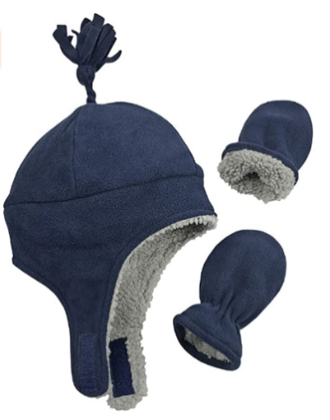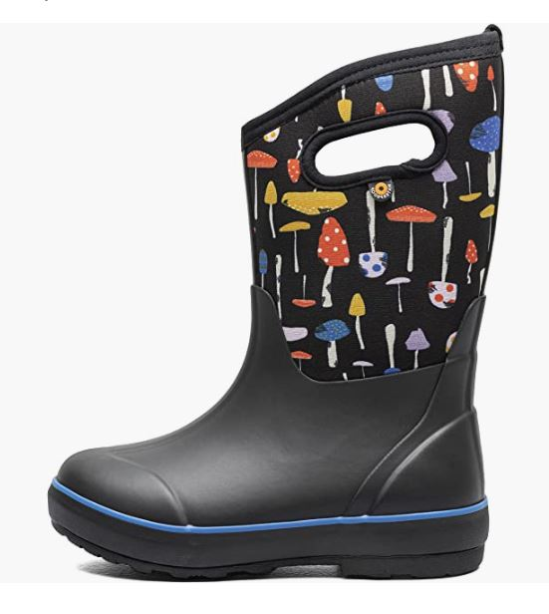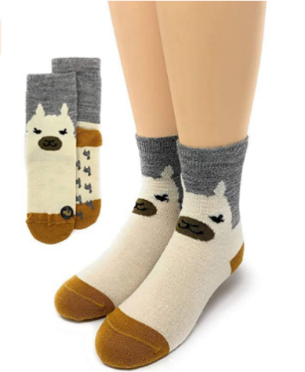

- Warm hat that covers the ears. Your child’s hat is one of the most important pieces of their kit. Check for comfort (well-fitting, not itchy, no scratchy tag) so that your child will keep it on their head. Fleece-lined hats that close under the chin are a great choice—cut long strings so they don’t pose a strangulation hazard during activity. Hoods can be added over hats, not in place of.
- Mittens. Mittens keep the hands warmer than gloves. The type of thin cheap gloves sold at dollar stores are not sufficient for warmth. Waterproof mitten shells over a pair of good gloves is an ideal combo. Don’t forget to label hats and mittens!!
- Socks and water-resistant shoes. Footwear is extremely important. Your child will be running around more than usual and kids don’t often notice when they’re getting blisters. Fit is very important to keeping feet warm and comfortable—too much space inside and feet get cold; too tight and feet have low circulation (and this also causes feet to get cold). Check the fit of boots with the socks you plan for your child to wear.
Keeping feet dry helps prevent several kinds of foot issues. Rain boots are the best choice for most weather—there are year-round wet areas in our outdoor space.
When you get home with wet boots, blot them dry with a towel, pull out the insoles and hang them up or pop them in the dryer, then stuff the boots with loose wads of newspaper. Change the newspaper after 2-3 hours, or prop the boots in front of a fan to finish drying. Optionally, you can buy two pairs of boots to rotate, or look for quick-drying boots when shopping. Clothes dryers will shorten the life of most rainboots.
Wool socks are worth the investment because they provide the best protection for feet and will keep feet warm even when wet. Look for the highest percentage of wool on the label and at least a midweight (or medium cushion) for the most durability. A couple of good quality options:
Smartwool socks
Darn Tough socks
Generic wool blend socks
- Extra socks packed--ALWAYS. At least one pair, packed in a sturdy ziplock or another waterproof bag.

Additions for hot weather –Sun hat, sunglasses, sunscreen
- Wide-brimmed sun hat. Comfortable boonie hats for children with cords to secure them on your child’s head (e.g. Sunday Afternoon or i play brands) are invaluable in breezy conditions. A wide-brimmed hat gives better protection to the ears and neck than a baseball cap.
- If desired, sunglasses with UVA/UVB protection.
- Sunscreen on exposed skin. Please apply sunscreen before dropping off your child. During times of mosquito activity, you may apply your preferred insect repellent as well.
- Please remember to stick with closed-toed shoes. Sandals that protect the toes, like Keens, are OK.
Additions for very cold weather—(Optional for Spring Quarter: Scarf or balaclava, wool socks or winter boots)
- Increase insulation for the feet with thicker socks, or switch to insulated winter boots.
- A hooded jacket, scarf or neck warmer helps seal out drafts around the neckline. Scarves and neck warmers add protection for the face and keep little noses toasty.
- Pack an extra fleece.
Please note that these are the clothing requirements for Spring Quarter. Fall and Winter quarters have additional clothing requirements. We have partnered with online retailer Biddle and Bop (no affiliation) who specialize in outfitting kids for outdoor school, and we will announce their shopping event for fall and winter clothing in June or July. We’ll provide additional guidance for fall and winter clothing at that time.
Outfit Examples
Example 1: A chilly, partly cloudy day
Wear: A thin synthetic shirt, a sweater, a warm pair of sweatpants, rain paints, thick socks and rainboots
Pack: Warm hat, mittens, fleece jacket, raincoat, baseball cap, extra socks

Example 2: A rainy, cold day
Wear: A thin synthetic shirt, a sweater, rain jacket, a warm pair of sweatpants, rain pants, baseball cap, thick socks and rain boots
Pack: Warm hat, mittens, waterprrof mitten covers, fleece jacket, extra socks

Example 3: A very cold day (Note that cold weather calls for multiple mid-layers!)
Wear: One or two thin synthetic shirts, a sweater, a fleece jacket, a rain jacket, a pair of leggings, a warm pair of sweatpants, rain pants, thickest socks and rain boots (or winter boots), a warm hat, mittens
Pack: An extra sweater or jacket, a neck warmer, extra socks

Example 4: A warm, partly cloudy day
Wear: A thin long/short-sleeved shirt, a pair of shorts or leggings, socks and rain boots (or sandals), sunscreen
Pack: A fleece jacket, rain coat, rain pants, a wide-brimmed sun hat, extra socks

