Dressing your child for the outdoors
The first priority is choosing clothing that will keep your child warm and dry. If your child has a pair of sound rain boots and a waterproof rain coat and rain pants, you’re most of the way there. Specialty outdoor clothing is likely unnecessary. Before you start shopping, “shop” your child’s existing wardrobe to identify pieces that fit the following criteria; you may be surprised how little you need to add. Tip: If most of your child’s clothing is cotton, start stocking up on fleece layers wherever you find them—and fleece pants and sweaters can be found at many garage sales and thrift stores.
Your child needs to bring three layers of clothing to school: A base layer, mid layer, and outerwear. They also need to bring appropriate protection for hands, feet, and head. What does this mean?
Base layer—Shirt and pants
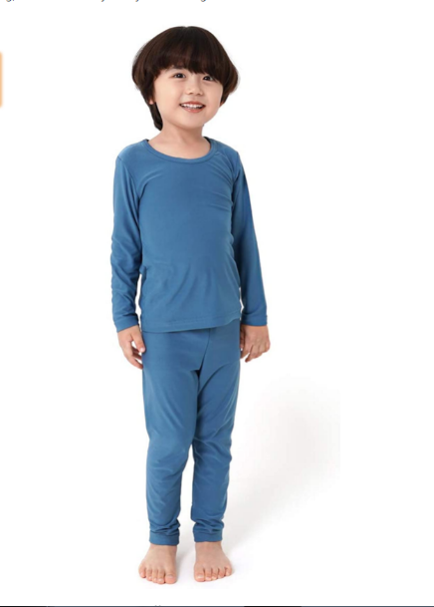
The base layer is worn closest to the skin. You don’t need to purchase special thermal underwear to serve as a base layer. By far the most important thing about the base layer is simply that it’s not made from cotton—cotton will not wick moisture away from the body and whether from the elements or from sweat, cotton becomes damp and chills the body.
Wool makes a wonderfully warm and breathable base layer, but it’s very expensive, and you’ll want to look for thin, stretchy wool pieces (usually marketed specifically as base layers, or possibly as pajamas) for this layer (By all means, snag chunky wool sweaters for your child’s mid layers!).
The best option for most families will be synthetic fabrics: polyester, nylon, etc. You’ll want to be able to fit your child’s other layers over his base layer, so look for thinner and closer-fitting synthetic clothes with plenty of stretch, like thin fleece or athletic apparel like yoga pants, long-sleeved sports tees, or lighter sweats. Costco sells Kirkland brand thermals (make sure that you don’t purchase cotton) and Amazon has inexpensive options for synthetic thermal underwear:
https://www.amazon.com/dp/B01HEZMR6I/ref=twister_B0776BNXZS?_encoding=UTF8&psc=1

Mid Layers: Sweater/s or a coat

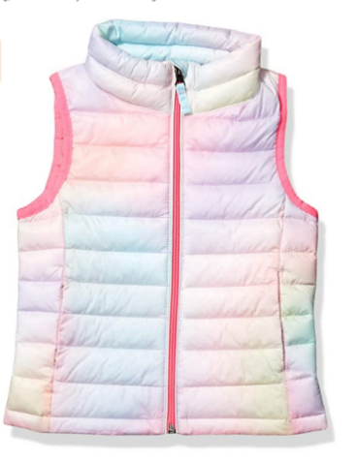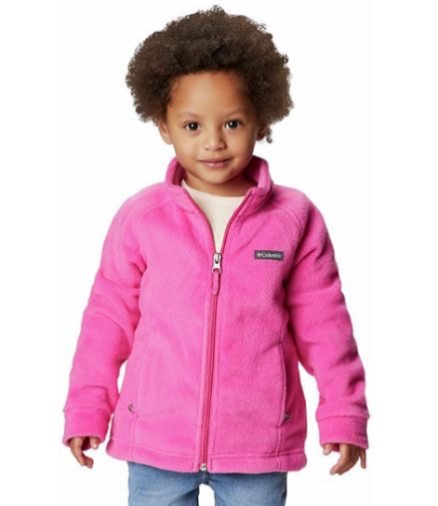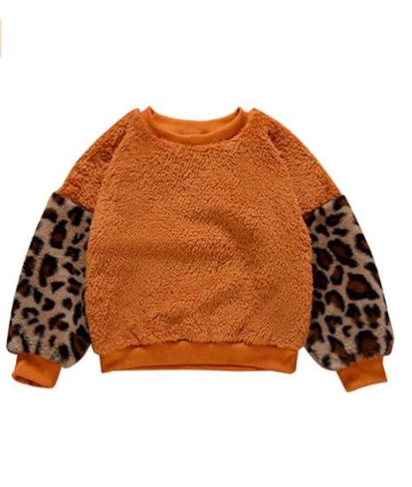

The mid-layer is about adding warmth. Thicker is not necessarily better. Trapping heat is the name of the game, and layers trap heat most efficiently; two thin shirts layered together may trap more heat than one sweater. Additionally: the more layers, the more versatility. The least versatile choice is a big puffy polyester-filled coat with a built-in waterproof outer layer. If these layers at least zip apart, your child has more options when, for instance, it’s rainy but she’s running around and feeling warm. My preference is to avoid polyester-filled coats altogether and just layer sweaters/fleeces. As well as offering better temperature control, layering traps more heat and keeps kids warm with less bulk. Wool and fleece are the best material choices for mid layers, but as long as you avoid cotton, just about anything will do.
How many mid layers do you need? As a rule of thumb, dress your child for comfort based on the conditions and have at least one extra mid layer packed in her backpack. On very cold days this could mean several mid layers (and/or double base layers—my favorite trick for warmth without bulk!).

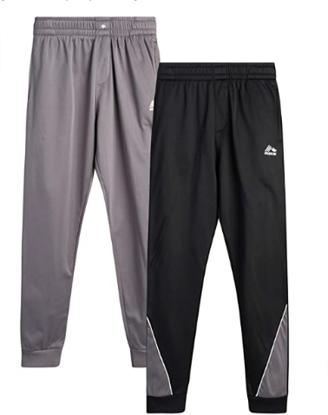

You’ll want to own pants for your child in a mid-layer weight, but you won’t need a lot in this category. Two layers of pants per day, including rain pants, is typically the maximum for spring weather. Choose either a base layer, like leggings, or a mid-layer, like thick fleece or polyester sweatpants, to wear underneath rain pants. Avoid jeans! In fall/winter, you may like the simplicity of snow pants, however, I have always used layers under rain pants and that works great too. Doubling up on base layers is a lot less bulky than trying to double up mid-layers. In the coldest weather I like using two pairs of base layer pants, one pair of thick sweatpants, and rain pants.

Outer layer – Rain coat and rain pants
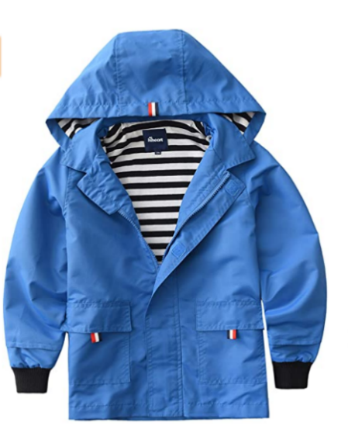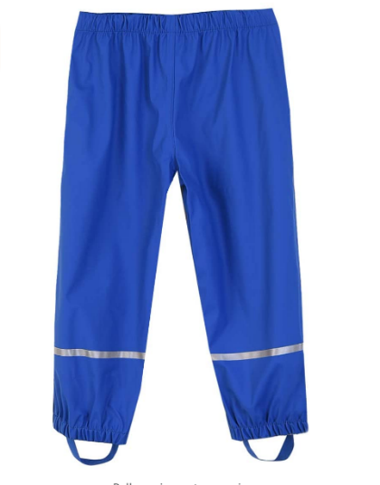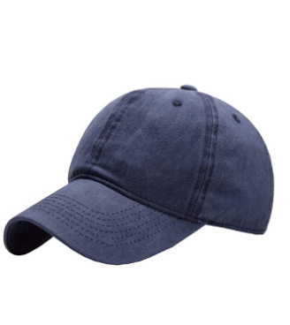

Your child is required to have rain pants to attend Chickadee Hollow Preschool. They must also have a rain jacket. Don’t confuse windproof material with waterproof. Again, for your primary pieces it’s better to avoid waterproof clothes with built-in insulation like all-in-one winter coats and snow pants—these are fine, just not very versatile. Instead, look for thin waterproof outer layers.

You’re welcome to choose rain suits that combine coat and pants, like Muddy Buddy brand suits. Have your child practice taking the suit on and off for bathroom breaks.

My preference is the brighter colors, the better—keep kids visible!

A rain jacket with a stiff hood will help keep the rain out of your child’s eyes, or he can wear a baseball cap with a stiff brim under his raincoat’s hood.

Often, expensive waterproof-breathable garments like Goretex lose their waterproofing with wear. Don’t despair, they have plenty of life left: refresh old or thrifted garments with a quality waterproofing product such as Nikwax.

Amazon has some inexpensive options for rain pants:
https://www.amazon.com/dp/B07T711T6T/ref=twister_B07T6215BP?_encoding=UTF8&th=1&psc=1
https://www.amazon.com/dp/B0764MMG1S/ref=twister_B00UXJ86V8?_encoding=UTF8&psc=1
https://www.amazon.com/dp/B08QS1LS38/ref=twister_B08PYT926Z?_encoding=UTF8&th=1&psc=1

Extremities – Hat, Mittens, Appropriate footwear

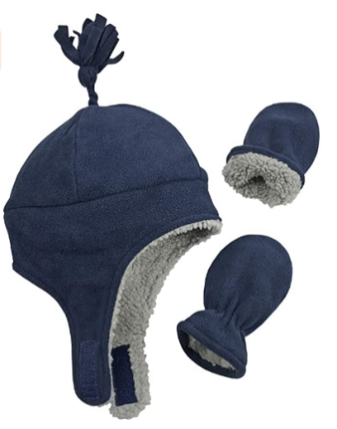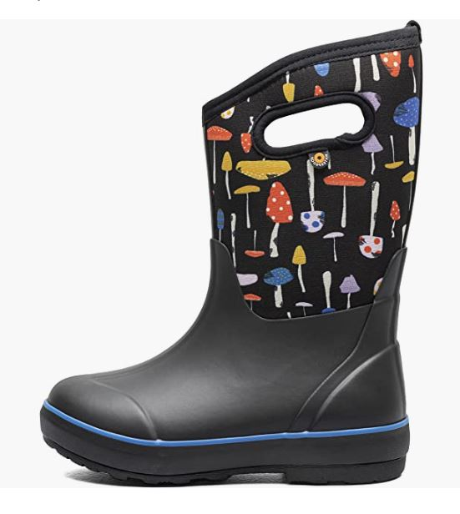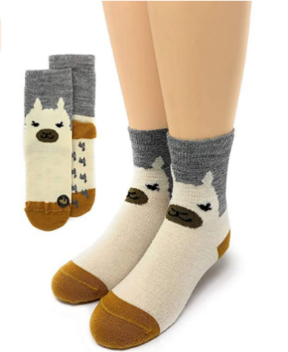

- Warm hat that covers the ears. Your child’s hat is one of the most important pieces of their kit. Check for comfort (well-fitting, not itchy, no scratchy tag) so that your child will keep it on their head. Fleece-lined hats that close under the chin are a great choice—cut long strings so they don’t pose a strangulation hazard during activity. Hoods can be added over hats, not in place of.
- Mittens. Mittens keep the hands warmer than gloves. The type of thin cheap gloves sold at dollar stores are not sufficient for warmth. Waterproof mitten shells over a pair of good gloves is an ideal combo. Don’t forget to label hats and mittens!!
- Socks and water-resistant shoes. Footwear is extremely important. Your child will be running around more than usual and kids don’t often notice when they’re getting blisters. Fit is very important to keeping feet warm and comfortable—too much space inside and feet get cold; too tight and feet have low circulation (and this also causes feet to get cold). Check the fit of boots with the socks you plan for your child to wear—their winter socks can be bulky!
Keeping feet dry helps prevent several kinds of foot issues. Rain boots are the best choice for most weather—there are year-round wet areas in our outdoor space.
When you get home with wet boots, blot them dry with a towel, pull out the insoles and hang them up or pop them in the dryer, then stuff the boots with loose wads of newspaper. Change the newspaper after 2-3 hours or prop the boots in front of a fan to finish drying. Optionally, you can buy two pairs of boots to rotate, or look for quick-drying boots when shopping. Clothes dryers will shorten the life of most rainboots.
Wool socks are worth the investment because they provide the best protection for feet and will keep feet warm even when wet. Look for the highest percentage of wool on the label and at least a midweight (or medium cushion) for the most durability. A couple of good quality options:
Smartwool socks
Darn Tough socks
Generic wool blend socks

- Extra socks packed--ALWAYS. At least one pair, packed in a sturdy ziplock or another waterproof bag.

Additions for hot weather –Sun hat, sunglasses, sunscreen
- Wide-brimmed sun hat. Sunday Afternoon and i play are two brands that make comfortable boonie hats for children with cords to secure them on your child’s head—invaluable in breezy conditions. A wide-brimmed hat gives better protection to the ears and neck than a baseball cap.
- If desired, sunglasses with UVA/UVB protection.
- Sunscreen on exposed skin. Please apply sunscreen before dropping off your child. During times of mosquito activity, you may apply your preferred insect repellent as well.
- Please remember to stick with closed-toed shoes. Sandals that protect the toes, like Keens, are OK.
Additions for very cold weather
- Increase insulation for the feet with thicker socks, or switch to insulated winter boots (Insulated boots are required for fall and winter quarters; optional for spring quarter).
- A jacket with an adjustable hood, a scarf or a neck warmer will help seal out drafts around the neckline. Scarves and neck warmers add protection for the face and keep little noses toasty. (A scarf is required for fall and winter quarters).
- Pack an extra fleece in their backpack.

Outfit Examples
Example 1: A chilly, partly cloudy day
Wear: A thin synthetic shirt, a sweater, a warm pair of sweatpants, rain paints, thick socks and rainboots
Pack: Warm hat, mittens, fleece jacket, raincoat, baseball cap, extra socks
_____________________________________________________________________________________
Example 2: A rainy, cold day
Wear: A thin synthetic shirt, a sweater, rain jacket, a warm pair of sweatpants, rain pants, baseball cap, thick socks and rain boots
Pack: Warm hat, mittens, waterproof mitten covers, fleece jacket, extra socks
_____________________________________________________________________________________
Example 3: A very cold day (Note that cold weather calls for multiple mid-layers!)
Wear: One or two thin synthetic shirts, a sweater, a fleece jacket, a rain jacket, a pair or two of leggings, a warm pair of sweatpants, rain pants, thick socks, winter boots, a warm hat, mittens and/or gloves
Pack: An extra fleece or jacket, a neck warmer, extra socks
_____________________________________________________________________________________
Example 4: A warm, partly cloudy day
Wear: A thin long/short-sleeved shirt, a pair of shorts or leggings, socks and rain boots (or sandals), sunscreen
Pack: A fleece jacket, rain coat, rain pants, a wide-brimmed sun hat, extra socks

Full Shopping List (Don’t forget to “shop” your child’s closet!)
□ Backpack
□ Leakproof water Bottle
□ Bandana
□ Lunch box if desired
□ Personal items: hand sanitizer, chapstick, *sunscreen (apply before school)*
□ Waterproof bag and Ziplock bags
□ Rain boots, well-fitting and without leaks
□ Rain suit or rain coat
□ Rain pants
□ Base layer shirt and leggings/pants (synthetic)
□ Mid-layer shirt and pants (synthetic)
□ Warm hat
□ Wide-brimmed sunhat
□ Mittens or gloves

For fall and winter, waterproof outer layers MUST be waterproof. Fall and winter students add:
□ Insulated boots
□ Scarf or neck warmer
□ Wool socks

Optional:
- Extras: Particularly, an extra pair of boots to rotate, extra socks, extra mittens, and an extra fleece. In fall/winter, one of my favorite tricks is to get an extra set of base layers and wear them both together.
- A thermos for a hot drink
- Field notebook (I recommend an unlined, hard cover, small to medium size notebook), writing utensils, a pencil case
- A baseball cap for wearing in the rain
- Closed-toed sandals
- Waterproof rain mittens
- Sunglasses

