Welcome to Chickadee Hollow Outdoor Preschool!
We’re thrilled that you’ve chosen our outdoor preschool for your child! It’s a privilege to be entrusted with the nurturing and education of children and it’s our joy to take that responsibility. We’re so excited for this upcoming quarter!
We look forward to working with you to ensure the best possible experience for your child and a learning environment that suits their needs. Parents are our partners in creating a school experience that optimally benefits your child. Please review the information in this handbook carefully and reach out with your questions or concerns. Feel free to request a meeting with our director at any time.
At Chickadee Hollow Preschool, it’s our goal to foster lifelong curiosity and build foundations for learning while we work and play in our rain-or-shine outdoor classroom. We focus on facilitating the development of strong social skills, providing opportunities for movement and free play, and enjoying reading together every day.
As some of your child’s first teachers, we aim to be a source of growth and challenge for them, and also to be a soft landing place. We strive to be caregivers they naturally turn to for comfort and reassurance as they tackle bigger and bigger challenges.
At the heart of our vision is a picture of childhood as it was meant to be—fresh air, space to run, wild beauty, wiggling worms. It is our hope that the time we spend together at Chickadee Hollow Preschool nurtures your child in body, mind and soul. It does for us.
With joy,
Your Teaching Staff at Chickadee Hollow Preschool

Table of Contents
1… Welcome Letter
2…Table of Contents
3… Policies and Procedures
- Student Eligibility p. 3
- Application Process p. 3
- Tuition p. 5
- Withdrawal p. 8
- Teacher and Parent Volunteers p. 8
- Drop Off and Pick Up p. 9
- Illness p. 10
- Restrooms p. 10
- Parent Communication p. 11
- Life Events p. 11
- Birthdays p. 12
14…Educational Philosophy
- Books and Stories
- Science p. 17
- Art p. 17
- Social Skills and Practical Life Skills p. 18
19…Discipline
21… Daily Items to Pack for School
- Daily Essentials p. 21
- Dressing Your Child For the Outdoors p. 22
  - Base Layer p. 22
  - Mid Layers p. 23
  - Outer Layer p. 24
  - Extremities: Hat, Mittens, Appropriate Footwear p. 25
  - Shopping List p. 27
29… Your Child’s Transition to Outdoor Preschool
30… Safety
32… Calendar

Chickadee Hollow Preschool Policies and Procedures

2023-2024 Director: Janelle Sawyer
Email: chickadeehollowpreschool@gmail.com
Phone: 425-530-2358
Mailing address: 105 E. Cox Ave. #15, Arlington, 98223
Preschool location: Haller Park: 1100 West Ave, Arlington, 98223
Program: 9am-12pm Tuesdays and Thursdays (school closures listed on calendar below) for ages 2.5-5 children who are toilet trained before the start of classes.
Website: chickadeehollowpreschool.com
Facebook: https://www.facebook.com/104886181399615

STUDENT ELIGIBILITY
Children are eligible for the 2024-2025 school year if they will be at least 30 months old and no older than 5 years on August 31, 2024. Children must be able to use the toilet with minimal assistance and without prompting.

APPLICATION PROCESS
Application form
The first step of the application process is to fill out one of our application forms. Our team will contact you within three business days to schedule your in-person interview. Applications may be accepted until August 31, 2024, however, when spaces are full, enrollment for Fall 2024 will close. Order of applications is based on the date of the interview. We strongly encourage you to apply early to get the earliest interview date.
Your child’s immunization record must be submitted with your application. This form can be requested from your doctor’s office or you may request an exemption form from our director.
Interview
The next step is for you and your child to meet with our director for an informal interview. These meetings are intended to be very casual, fun affairs; siblings are welcome, and we meet on location at Haller Park so you can see where drop-off and pick-up happen each day of school--hint: wear your walking shoes! The purpose of the interview is simply to make sure your child is a good fit for our preschool and our preschool is a good fit for your child, mutually. It will not function as an evaluation of your child. You will be notified of the final status of your application by email within two business days.
Application fee
The application fee is $90. Of this deposit, $45 is nonrefundable to cover administrative costs, while the other $45 is applied to the last tuition payment of the quarter (or deducted from the annual payment). You will be notified of the final status of your application by email within two business days.
Trial period
We appreciate a commitment to the school year and ask for at least a quarter-long commitment in an effort to provide our students with a stable cohort of long-term classmates. However, we want to ensure you’re happy with your child’s program. Families may try out the program for the first two weeks of any quarter to decide if they’d like to commit. They will need to complete the application process including interview and pay the required tuition, as described below. If they choose not to continue, they will receive a refund of any monies over and above the first two weeks’ prorated tuition, application fee, deposit, and a $75 processing fee.
Waitlist: When our program is full, we will notify families currently in the enrollment process or interested in beginning the enrollment process that acceptances will be to our waitlist and no guarantees will be made that a space will become available. If a space does become available, the application fee will be required to be paid in full within 5 business days of notification and your child must begin school by the first day of the following month, or optionally may begin earlier with pro-rated tuition. Students must be added to the waitlist by the application deadline, or they will be placed on the waitlist for the following quarter.

TUITION
Families are required to enroll for at least one quarter; however, a monthly payment schedule is available. Optionally, families can enroll in the full school year at a 5% discount. To enroll in the full school year, families must select the annual payment schedule (below). Siblings can be enrolled for a 3.5% discount, or a maximum 8% discount total for siblings enrolling with the annual tuition discount.​
​Families who pay in full for the school year guarantee a space for their child in fall, winter and spring quarters. Otherwise, students must reapply and pay another application fee for each quarter, however, priority will be given to matriculated students. Repeat interviews are not required for subsequent quarters in a school year, whether enrolling quarterly or annually. Application due dates are August 31 for fall quarter, December 31 for winter quarter, and March 31 for spring quarter.
Tuition costs

​Tuition is on a sliding scale. The base tuition cost is listed first. Families may choose to pay the silver tier or gold tier tuition rate. 100% of silver and gold tier tuition above the base cost goes directly to covering tuition costs for families with demonstrated need. Gold tier families fund a full scholarship for one child, and silver tier families fund a 75% scholarship.
​
Tuition Choices:
​
Annual tuition (5% discount): $3,377
Silver tier: $3,940
Gold tier: $4,503

Quarterly tuition $1,185 per quarter
Silver tier: $1,383
Gold tier: $1,580

Due dates for 2024:
Annual: August 31, 2024
Quarterly: August 31, 2024, December 31, 2024, and March 31, 2025
Payment schedule: Due by the last day of the month.

Optional payment schedule. Monthly payments are available for any tuition tier. The base tuition payments are as follows: Fall quarter has 4 payments of $296. A 12-month payment schedule of $296 per month for qualifying families is detailed below, otherwise winter and spring have 3 payments of $395. Fall quarter has breaks for Thanksgiving and Christmas, thus fall quarter is divided into four payments.
Monthly payment due dates for 2024-2025: Fall quarter is divided into 4 payments, due August 31, September 30, October 31 and November 30. Winter quarter is divided into 3 payments due December 31, January 31, and February 29. Spring quarter is divided into 3 payments due March 31, April 30, and May 31. Currently enrolled families as of spring 2024 who re-enroll have the option to pay $296/mo over 12 months (including during the summer when there is no school) to simplify your budgeting. This option is limited to families who are enrolled for the upcoming school year or to qualifying families who request an extended payment plan.
​
​Families with financial need: Families with a combined income of less than $83,267 (80% of the AMI in 2024) are eligible to be placed on a subsidized waitlist and will be offered a space as soon as funds are available. Families with financial need pay $790 per quarter, or $2,251 per year, and the remaining tuition cost is subsidized by other families in the program. Families needing additional assistance are encouraged to seek external scholarship opportunities or request an extended payment schedule of $198/month for 12 months.

Subsidized waitlist: Families who wish to join the subsidized waitlist should submit a full application including immunization form, beginning at 12:00AM on March 25, 2024. Early applications will not be accepted. Families cannot be on the regular waitlist at the same time as the subsidized waitlist. The subsidized waitlist will only be used if funding is available to subsidize tuition. The waitlist will roll over from quarter to quarter automatically until March 25, 2025. Families who wish to join the subsidized waitlist for the 2025-26 school year will need to reapply at that time. Applications for the subsidized waitlist can be submitted at any time. Spaces will always be offered in the order applications are received, regardless of which waiting list families are on, however, if no funding is available, the subsidized waitlist will be skipped. Families who wish to move their application from the subsidized list to the regular waitlist may do so at any time, however, the date they move to the regular list will become their new application date. Income verification will be requested at the time an offer is extended for a space on the subsidized list, and an updated application and immunization form may be requested.
​
Tuition covers all costs of attendance; there are no additional fees related to regular school participation, materials, guest speakers, or any other special events during school hours.
Invoices are sent 1 week prior to due dates. Payments are accepted by cash, check, money order, Venmo, or Paypal. Checks are preferred, especially for quarterly and annual payments, because transaction fees are calculated as a percentage of the payment. Payments should be made out to Chickadee Hollow Preschool. Venmo: https://venmo.com/code?user_id+3347648346062848960.
Late payments
Late payments or returned checks are subject to a 5% penalty. More than 5 days late without communication may result in the forfeiture of your child’s space in school. Families paying monthly or quarterly are committed for the quarter they signed up for. Families are responsible for making payments through the end of the quarter, regardless of the child’s attendance. No refunds will be issued for missed school due either to your child’s absence or to emergency school cancellations.
School closures: If snow or inclement weather affects the safety of staff and students during transportation to school, we will usually follow the example of Arlington public schools in deciding to close or remain open. If Arlington School District implements a late start of 2 hours or more, Chickadee Hollow Preschool will usually be canceled. Specific to outdoor education, air quality warnings of AQI 151 or above, high winds above 25 mph sustained or above 45 mph gusts, lightning close by, and extreme temperatures above 100° in the shade or below 20° affect whether we can remain open safely. School cancellations will be communicated by email by 7am the day of closure, and efforts will be made to communicate with parents via email the night before if a possible closure is indicated by the weather forecast.
Withdrawal
Withdrawing your child is at the discretion of the director, unless an active military parent is relocated, in which case please provide as much notice as possible before your child’s last day. For other withdrawal requests after the first two weeks of a quarter, please submit these in writing to the director at least 21 days before your child’s last day and expect to be responsible for the following month’s tuition unless a new student is found to fill your child’s space. Once parents make a commitment to the school, staffing and materials are prepared for the year to meet the students’ needs; application fees are forfeited in the event of withdrawal.

Teachers and Parent Volunteers
Parents are always welcome! You may stay as long as you like. All of our teachers are required to complete a background check and take a first aid and child CPR training. No one is allowed to supervise any student or group of students independently without verifying these requirements. Any volunteer who will be around students on a regular basis, even with other teachers present, is required by Washington State’s licensing department to have a current background check on file. Parents who wish to participate in a volunteer capacity must complete a background check and a first aid and child CPR training. If you have a particular skill or knowledge to share as a guest teacher, please get in touch! One-time guest teachers will not be alone with any group of students and may waive the background check and safety trainings.
Parents who are accompanied by pets or other children must leave the area once school has begun; infants or pets in carriers are welcome to accompany parents.
We allow prospective parents to attend class with their children to tour the program. Touring parents are never allowed to be alone with any child/children in the program and their behavior must comply with our standards.
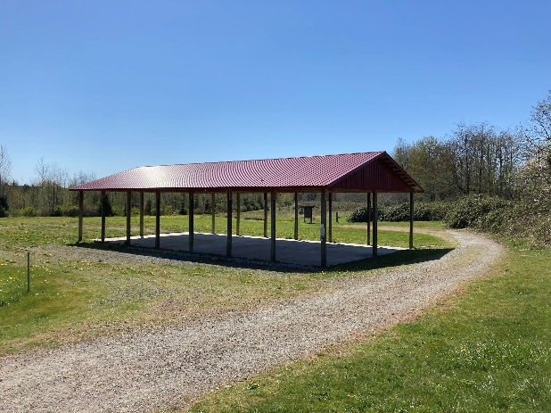
Drop off and Pick Up
Please be aware that our drop off location is a short distance from the parking lot. You will need to plan enough time to walk your child from the parking lot to the shelter, which is the covered area where school starts each day (The Stormwater Wetland shelter in the Eagle Trail area accessed from Haller Park parking lot). When you arrive, you will need to take your child to a teacher to sign them in before you may depart. This walk is a valuable part of your child’s school day! It offers a transition period into school that gives them time to adjust to what’s coming next in their day. Parents can maximize this by allowing plenty of time so you don’t need to rush and putting away phones or other distractions while walking.
Children will walk with their teachers to the pick-up area. Kids will stay within the fenced area while waiting for pick up. Pick up will be at the entrance to the Eagle Trail at the Haller Park parking lot. We are often returning from the opposite end of the park, and while we make an effort to be punctual, occasionally the class is a few minutes late arriving to the pick-up area. We request your patience and suggest that you wait for us to come to you, since we approach the pick-up area from various locations/directions; if you are anxious about making it to an appointment after class, please let us know at drop-off so that we can be sure to allow enough time.
Only a parent or a preauthorized caregiver may pick up a student. To authorize someone to pick up your child, you will need to submit a copy of his or her photo ID in advance. Anyone your child’s teacher doesn’t recognize will be asked to show their photo ID and be matched to a photo ID or emergency contact on file before he or she may leave with your child.
Late pick-up: If you are more than 5 minutes late, it will be considered a late pick-up. Late pick-ups cost our school for staff overtime. More than one late pick-up in a month will result in a late pick-up charge of $25 on the following month’s invoice or a separate invoice. If you are running late to pick up your child, please contact us by text or phone call at 425-530-2358. If we don’t hear from anyone and you are 10 or more minutes late, we will begin contacting the emergency contacts in your child’s file to arrange pick up.
Late drop off: If you’re running late to drop off your child, please call us at 425-530-2358. You will be responsible for walking your child to wherever the class is located at the time you arrive.
Absences: We appreciate being notified of absences 24 hours in advance, since we may be prepping materials. Please notify us as soon as possible otherwise; expect us to get in touch after any no-shows. Regular and prompt attendance is beneficial to your child and the other children in our cohort. Tuition payments will continue to be invoiced regardless of attendance.
ILLNESS
If your child is ill, please keep them home. If your child develops any symptoms of illness during school hours, we will contact you, or someone from your child’s emergency contact list if you are not available, to pick them up early. If your child has experienced any vomiting or diarrhea in the past 24 hours, or has a fever of 100.4 or higher, please keep them at home.
Restrooms
Prior to enrollment, we require that students can use the toilet without prompting and with minimal assistance, meaning we can help with verbal encouragement. If a child were to have an accident, for instance, we can coach her to change her pants, but if it's beyond what she's able to do on her own, we'd need to call the parents because we don't have the facility and sanitary requirements to change kids. There is a public restroom with running water open year-round at Haller Park we can use. However, it's a long walk for the kids, so we have a potty chair (pack-it-out style that the teacher packs out at the end of the day) in a private area a few yards from our main location so that the kids can make it to the toilet quickly when necessary. A teacher will provide supervision of the portable toilet while kids are using it. Children are also welcome to take a “forest pee,” and teachers will guide them to select an appropriate location.
Parent Communication
If your child is hurt during school, we will provide you written communication about the incident the same day, and if it’s a more urgent concern we will call you. We encourage parents to promptly read all emails from school to stay up to date on communications. Urgent information, such as school closures or information specific to your child will be communicated directly to parents by email. We encourage you to reach out whenever you have questions or concerns at chickadeehollowpreschool@gmail.com or by phoning our director, Janelle Sawyer at 425-530-2358. Our philosophy is that regular communication is an important part of maintaining healthy relationships, and that additional communication should be sought and followed up on when issues arise. We value our relationships with parents and we may reach out to you to set up a conference if there is an issue pertaining to your child.
Life Events
It is helpful for us to know if there have been any major changes in your child’s life, such as the birth of a sibling, divorce or separation, a move, illness or death of a family member, etc.

Birthdays
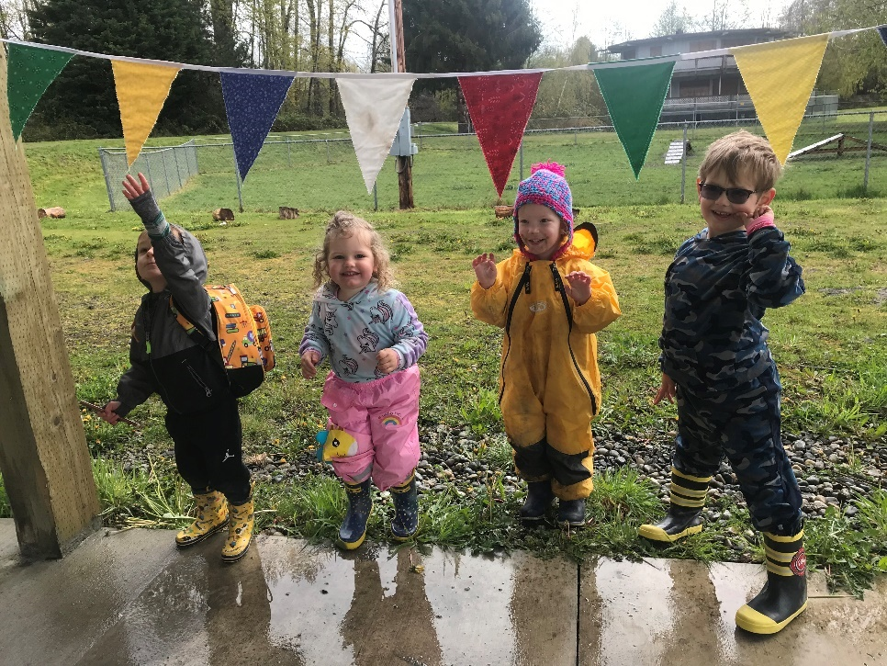
Birthdays mark milestones worthy of celebration! Our birthday policy is designed to honor the Birthday Boy or Girl, shower them with attention--as desired, and enjoy the ritual of a birthday party with decorations, song, and healthy treats. Parties are about celebrating together, therefore all children must be able to participate (see Birthday Treats). Additionally, each child deserves their chance in the spotlight, therefore we have “standardized”—as of the 2023-2024 school year—our school birthday celebration to give each child the following set of birthday honors to look forward to:
- The birthday child will receive a Birthday Crown from the teacher to wear all day at school
- We will put up the school Birthday Decorations: Triangle flags banner
- We will read the birthday child’s favorite book, if provided
- If the birthday child would like, we will sing the traditional American birthday song together
- Treats for the class, if provided by a parent
- A special (small) birthday gift from the teachers (card, pencil and eraser)
Please feel free to discuss with the director beforehand alternate preferences your family has for your child’s birthday. Please do not send additional items unless they have been approved; save these items for your celebrations at home: beverages, candles, goodie bags, gifts etc.
If you’d like to invite your child’s friends from school for a party, we ask that you offer invitations to all the kids in the class.
Birthdays that fall on weekend or non-school days will be celebrated the day before the birthday or the beginning of the break, unless otherwise requested. The Summer Birthday Club will have their celebration in the final week of Spring Quarter.
Birthday Treats
If you would like to bring food or non-food treats for the class, please have them approved by the director in advance. Our school policy is to avoid sugary snacks, and we maintain this policy for treats, however there are many healthy ideas that can be celebratory: Consider 100% fruit popsicles, apple ring “donuts” topped with cream cheese and rainbow sprinkles, using cookie cutters to make sandwich “petit fours” with nut butter and seed “sprinkles” (sprinkles are always festive!) etc. In any given class, these and other ideas may require modifications to ensure all the kids are able to participate. This is why it’s important to discuss your ideas with the director in advance. Parents who wish their child to have a more low-key celebration at school are welcome to skip any of the following.
Parent-provided options for birthdays
- A food/non-food “treat” item that has been approved by the director, for every child
- Any plates, napkins, or silverware needed for treats
- Birthday child’s favorite book to share with the class

EDUCATIONAL PHILOSOPHY
How should we prioritize children’s time at the youngest ages? This is the central question that guides the educational philosophy of Chickadee Hollow Preschool. Experts recognize that early childhood is a sensitive time for the kinds of learning kids do through open-ended play, being in nature, and interacting with people. Balancing these activities is more art than science.
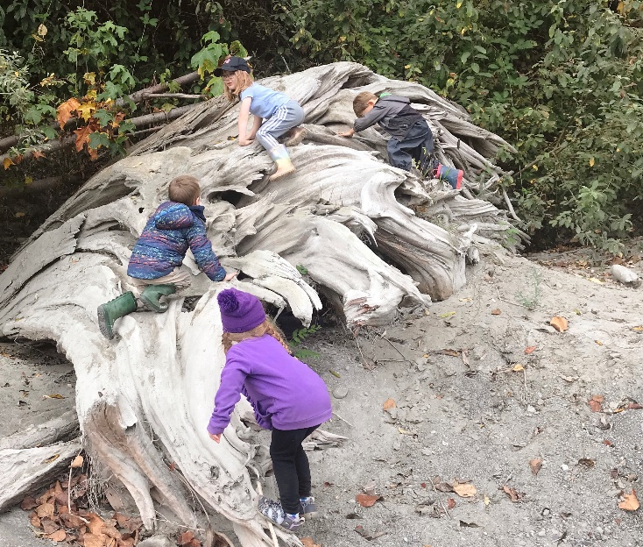
Developmentalist Jean Piaget said, “Play is the work of children.” Montessori programs take this concept seriously, advising adults to avoid interrupting the child deeply immersed in play, just as adults appreciate not being interrupted when concentrating on work. One of the first revolutionary notions to arise from developmental science was that play, observed in the young of numerous species across the planet, has important functions that translate into real skills. How best to facilitate play-based learning for kids?
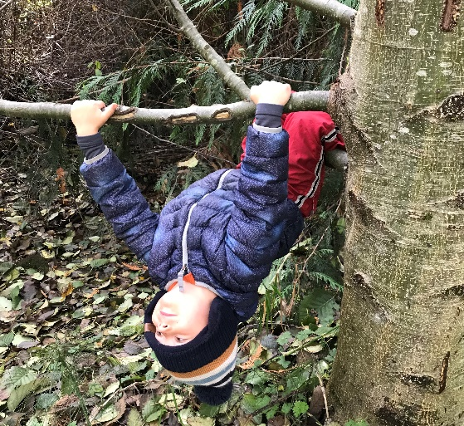
Gross motor play is what kids do with their whole bodies (in contrast to fine motor activities that they do by holding pencils and other small instruments to accomplish delicate tasks). Gross motor play is fantastic exercise. It strengthens muscles, develops coordination, exercises the heart and lungs, and improves balance. Play on natural materials like logs and uneven ground surfaces, rather than built environments like plastic playground materials and sidewalks, is especially effective at shaping a strong and agile body. Using the large muscles for running and jumping keeps kids warm. On cold days, we find ways to encourage a lot of movement. Many children who show signs of attention deficits have greater needs for physical movement in their day to nourish their brains. All kids feel better when they get enough movement. It’s also helpful for falling asleep easily and getting quality sleep, which has a major impact on children’s learning. Movement is a cornerstone of a healthy life and a feature of every day at Chickadee Hollow Preschool.
We are protective of the time that our students get for free play, meaning we will not schedule their whole day with structured activities. Likewise, as educators, we take advantage of opportunities to educate and make connections in the direction of lifelong learning. Our balance of free play and structured learning evolves in collaboration with the students and their interests. We aim to scaffold children’s natural curiosity into the types of intentional learning that optimize the opportunities presented by the developmental window of early childhood.
We always want to make sure that a child’s first experience with school is full of joy and that they like to be there as much as possible. For many children, sitting and listening is not what they want to be doing (for many others it’s what they like best—all kids are different!). One way that we ensure our teaching time doesn’t over-draw from kids’ play time and that it fits our students’ needs by implementing an emergent “curriculum”—one custom-designed for the class week by week.
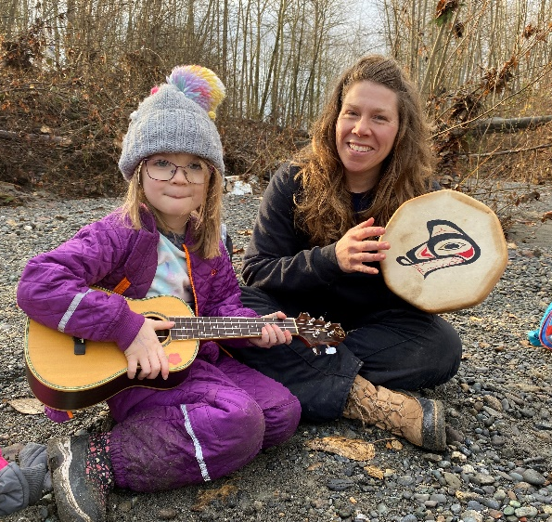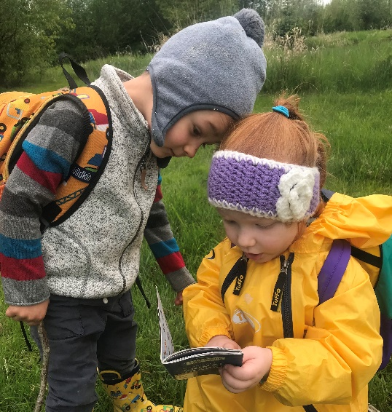
Our emergent activity plan is designed to be developmentally appropriate for pre-school age children. That means we focus on foundational skills: We cultivate a school environment that builds foundations for learning and life. The most important goal we have is to foster curiosity.
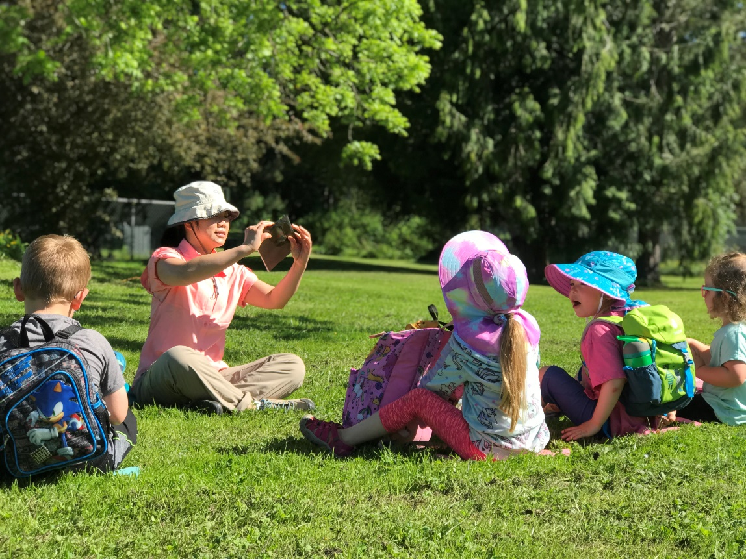
Books and Stories
We believe in the importance of taking the time to read books together every single day. Storytime has always been a central component of our circle time, whether reading books, intentionally practicing pre-literacy skills, or telling stories with story boards, finger puppets, or other storytelling objects. We find ways to engage each child during story time, and we offer access to our library of books, rotating according to the current theme, during free time.
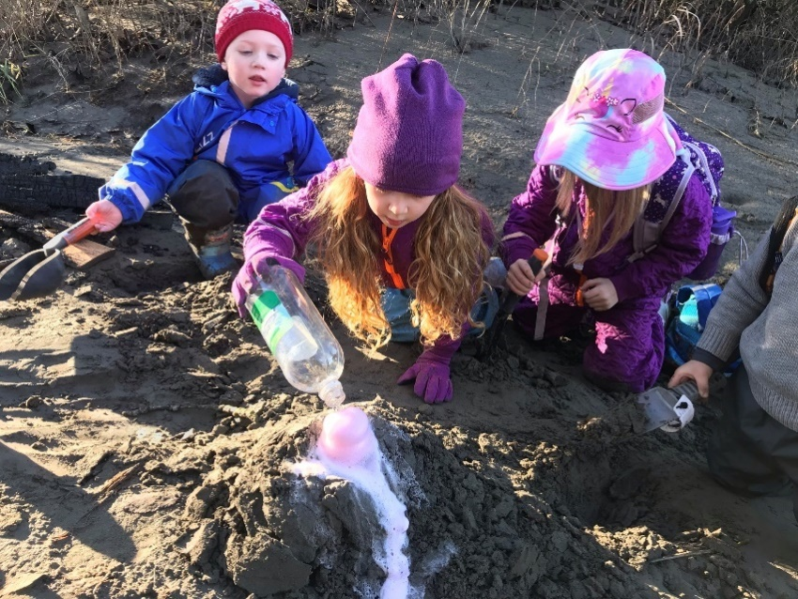
Science
Science is a natural topic for outdoor education. We have found that our emerging themes are often organized around science concepts because these are foundational to many of the questions that arise in a nature setting. We love to answer questions with questions, or by setting up experiments. This is an approach to teaching that teaches reasoning, self-directed learning, and curiosity, and helps develop a scientific framework for studying the world.

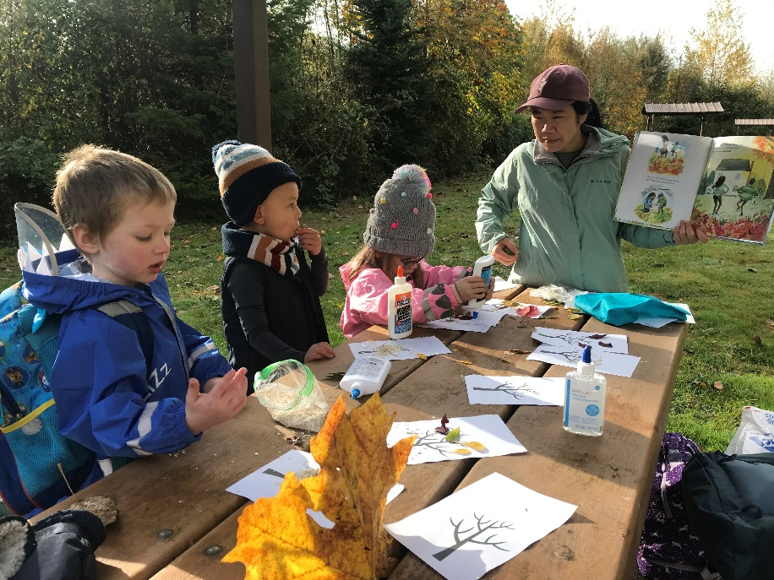
Art
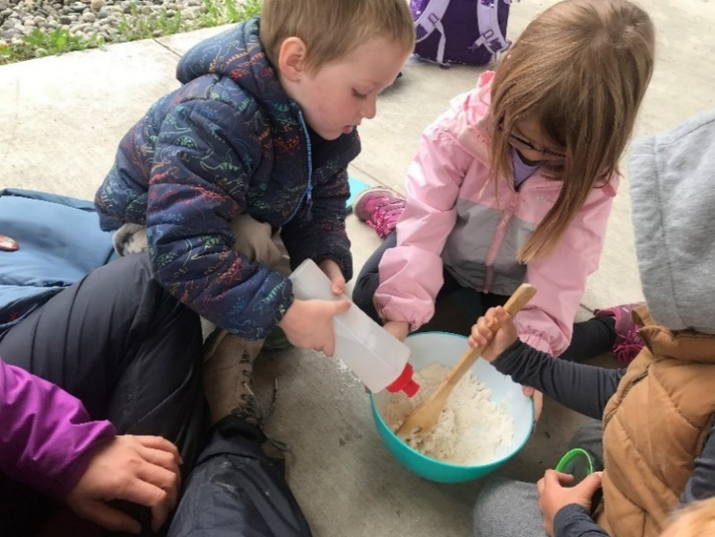
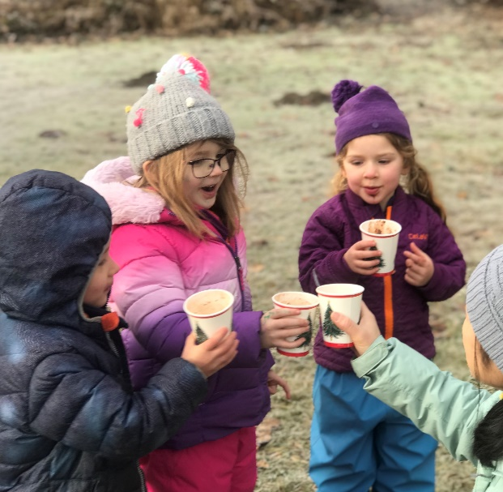
Art is playful. Art also supports other concepts being taught, and teaches functional skills like pencil grip, scissors skills, using paintbrushes, glue, dough, and other mediums. It takes good fine motor skills to put a googly eye right where you want it! These activities are great for preschool kids because they simply take practice (lots and lots of practice) to master them, and then the sky is the limit on kids’ creativity. Clear some space on your fridge, shelves, and walls. You are going to have lots of art to showcase in the coming months!

Social Skills and Practical Life Skills
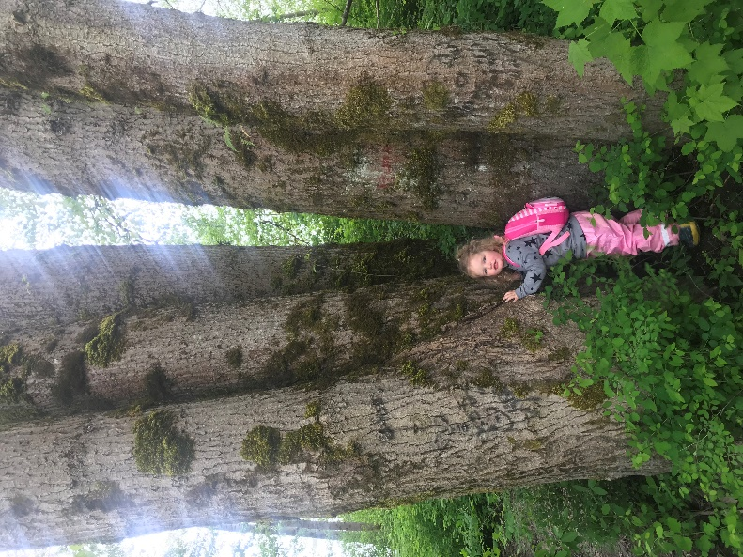
We occasionally teach functional skills and social skills in a structured way, but much more often, learning opportunities arise during play. These include sharing, taking turns, resolving conflict, empathy, self-regulation, manners, respect, perseverance, friendship, and bravery.
We support kids as they gain independence in mastering functional skills like tying shoes, putting on gloves, zipping, snapping, and buttoning clothing, and manipulating objects for self-feeding and self-care.
Early childhood can be thought of as an awakening. The budding mind just needs the right conditions to bloom.

Discipline
The root word “disciplina” means “to teach,” and that is the goal of discipline at Chickadee Hollow Preschool. We have rules that kids need to follow for their safety, and expectations for their behavior toward their peers, their teachers, their environment, and themselves. We will consistently and gently correct behavior that falls outside of the rules and expectations with the aim of creating an opportunity for the child to learn. How we accomplish this requires keeping in mind the developmental age of each child and may involve reminders, redirection, play/humor, consequences, or inviting children to reflect on their own behavior.
Healthy relationships are the cornerstone of healthy and happy life, and as children learn how to relate to others, it’s our goal to facilitate the development of strong social skills. These skills are arguably more important than any skills taught to children at this age. Children need lots and lots of practice navigating their own emotional landscapes and solving their interpersonal dilemmas and we offer guidance when it’s needed and quiet watchfulness when it’s not.
We do not use physical punishment under any circumstance.
If a behavioral issue is taking up significant attention from teachers, such as a prolonged tantrum or a child displaying an inability to follow rules after multiple reminders, the parent may be called to come and provide the individual attention your child needs, whether that’s removing the child for the day or another strategy.
If there is an ongoing behavior concern, we will invite parents to collaborate on a behavior plan. This may require meeting outside of normal school hours.
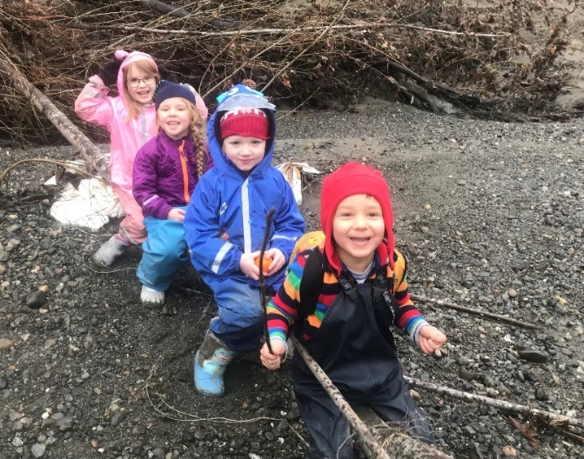
NonDiscrimination
Chickadee Hollow Preschool is an equal opportunity care provider. We do not discriminate in employment practices or client services based on race, creed, color, national origin, sex, age or disability.

Daily Items to Pack for School
It is essential that your child arrive at school with everything he needs to keep him safe in all potential weather conditions for that day. In the worst-case scenario, he won’t be allowed to stay at school with inadequate clothing if it’s deemed a safety concern by your child’s teacher. We also want kids to be comfortable enough to have fun and enjoy themselves!
The good news is that our maritime climate creates a lot of mild, predictable weather. Our foremost concern is staying dry in all the wet weather we get in the Pacific Northwest.
Planning is a crucial step for any outdoor excursion. We encourage you to involve your child in this process to learn the habit of being prepared. Checking the weather may become a favorite activity.
Expect all clothing to get filthy, especially boots, pants, and gloves/mittens. On wet days, you will likely want towels to protect the surfaces in your car, and you may want a clean, dry set of clothing ready for your child either in your home’s entry or to change into in the car if your child won’t be going home immediately (include dry shoes).
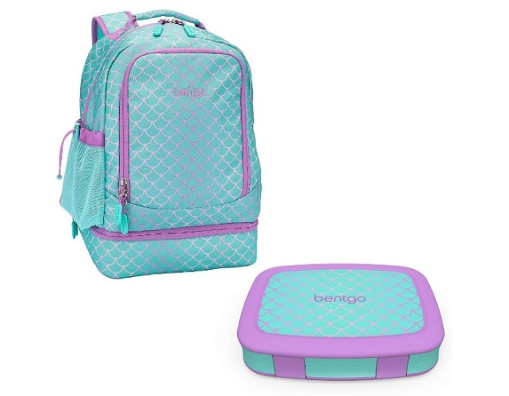
Daily essentials
Please label all of your child’s belongings and clothing with their name! We will do our best to avoid mix-ups, but we cannot be held responsible for lost, stolen or damaged items
- Backpack. Check that the backpack fits your child, so they can take responsibility for carrying their own things, and check that your child’s essentials will fit inside—many children’s backpacks are simply too small to hold their outdoor clothing.
- Water bottle. Your child’s water bottle needs to close tightly enough to prevent leaks when upside down in his bag. As many hikers have learned the hard way: all the warm, dry clothing in the world becomes useless when your water bottle soaks it inside your bag. Please do not fill water bottles with juice. Your child may bring a thermos with a warm beverage if desired.
- Bandana.
- A small snack that includes protein. The best snack choices don’t create a lot of mess if spilled; your child will most often be sitting on the ground during snack time. Unwrapping tricky wrappers before packing those items provides your child with self-sufficiency. Include some protein to keep your child’s blood sugar level even so their brain is at its best! Think nut butter pouches, apple slices, bananas, pepperoni sticks, cheese, crackers, carrot sticks, veggies, trail mix, etc. Please do not include candy or junk food. Some parents like bento boxes that have a tray a child can set on her lap as a makeshift table. Because of allergies, we discourage sharing and trading snack items with other students.
- Personal items. Personal-size hand sanitizer (Teachers also bring hand sanitizer and wipes for the class). Chapstick, especially on cold and windy days.
- Waterproof sack or plastic bag to contain any wet or soiled clothing (consider placing extra clothing inside to help ensure it stays dry!).
- Extra socks. Please ALWAYS pack an extra pair of socks for your child. Seal them in a ziplock bag.
- Optional: Field notebook and writing utensils, packed in a sturdy ziplock or other waterproof bag. We recommend choosing a notebook with blank, unlined pages to accommodate drawing and sketching. A hard cover helps to keep pages flat and create a surface for writing. We suggest sending 2-4 colored pencils as the writing utensils so your child can both write and draw. A whole box of colored pencils is likely too many to keep track of. A hard pencil case is handy for protecting pencils. Teachers bring pencil sharpeners.
- Please do not bring any toys from home.

Dressing your child for the outdoors
The first priority is choosing clothing that will keep your child warm and dry. If your child has a pair of sound rain boots and a waterproof rain coat and rain pants, you’re most of the way there. Specialty outdoor clothing is likely unnecessary. Before you start shopping, “shop” your child’s existing wardrobe to identify pieces that fit the following criteria; you may be surprised how little you need to add. Tip: If most of your child’s clothing is cotton, start stocking up on fleece layers wherever you find them—and fleece pants and sweaters can be found at many garage sales and thrift stores.
Your child needs to bring three layers of clothing to school: A base layer, mid layer, and outerwear. They also need to bring appropriate protection for hands, feet, and head. What does this mean?
Base layer—Shirt and pants
The base layer is worn closest to the skin. You don’t need to purchase special thermal underwear to serve as a base layer. By far the most important thing about the base layer is simply that it’s not made from cotton—cotton will not wick moisture away from the body and whether from the elements or from sweat, cotton becomes damp and chills the body.
Wool makes a wonderfully warm and breathable base layer, but it’s very expensive, and you’ll want to look for thin, stretchy wool pieces (usually marketed specifically as base layers, or possibly as pajamas) for this layer (By all means, snag chunky wool sweaters for your child’s mid layers!).
The best option for most families will be synthetic fabrics: polyester, nylon, etc. You’ll want to be able to fit your child’s other layers over his base layer, so look for thinner and closer-fitting synthetic clothes with plenty of stretch, like thin fleece or athletic apparel like yoga pants, long-sleeved sports tees, or lighter sweats. Costco sells Kirkland brand thermals (make sure that you don’t purchase cotton) and Amazon has inexpensive options for synthetic thermal underwear:
https://www.amazon.com/dp/B01HEZMR6I/ref=twister_B0776BNXZS?_encoding=UTF8&psc=1

Mid Layers: Sweater/s or a coat

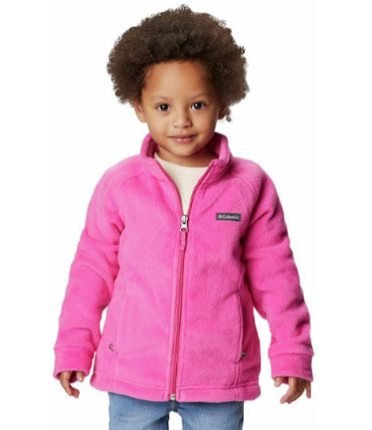

The mid-layer is about adding warmth. Thicker is not necessarily better. Trapping heat is the name of the game, and layers trap heat most efficiently; two thin shirts layered together may trap more heat than one sweater. Additionally: the more layers, the more versatility. The least versatile choice is a big puffy polyester-filled coat with a built-in waterproof outer layer. If these layers at least zip apart, your child has more options when, for instance, it’s rainy but she’s running around and feeling warm. My preference is to avoid polyester-filled coats altogether and just layer sweaters/fleeces. As well as offering better temperature control, layering traps more heat and keeps kids warm with less bulk. Wool and fleece are the best material choices for mid layers, but as long as you avoid cotton, just about anything will do.
How many mid layers do you need? As a rule of thumb, dress your child for comfort based on the conditions and have at least one extra mid layer packed in her backpack. On very cold days this could mean several mid layers (and/or double base layers—my favorite trick for warmth without bulk!).

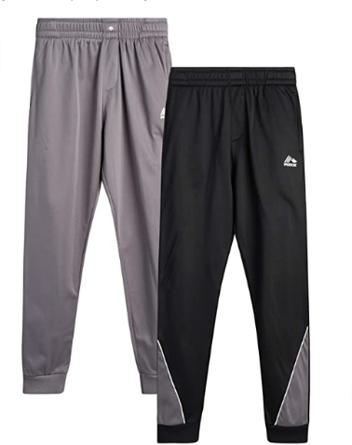

You’ll want to own pants for your child in a mid-layer weight, but you won’t need a lot in this category. Two layers of pants per day, including rain pants, is typically the maximum for spring weather. Choose either a base layer, like leggings, or a mid-layer, like thick fleece or polyester sweatpants, to wear underneath rain pants. Avoid jeans! In fall/winter, you may like the simplicity of snow pants, however, I have always used layers under rain pants and that works great too. Doubling up on base layers is a lot less bulky than trying to double up mid-layers. In the coldest weather I like using two pairs of base layer pants, one pair of thick sweatpants, and rain pants.

Outer layer – Rain coat and rain pants

Your child is required to have rain pants to attend Chickadee Hollow Preschool. They must also have a rain jacket. Don’t confuse windproof material with waterproof. Again, for your primary pieces it’s better to avoid waterproof clothes with built-in insulation like all-in-one winter coats and snow pants—these are fine, just not very versatile. Instead, look for thin waterproof outer layers.

You’re welcome to choose rain suits that combine coat and pants, like Muddy Buddy brand suits. Have your child practice taking the suit on and off for bathroom breaks.

My preference is the brighter colors, the better—keep kids visible!

A rain jacket with a stiff hood will help keep the rain out of your child’s eyes, or he can wear a baseball cap with a stiff brim under his raincoat’s hood.

Often, expensive waterproof-breathable garments like Goretex lose their waterproofing with wear. Don’t despair, they have plenty of life left: refresh old or thrifted garments with a quality waterproofing product such as Nikwax.

Amazon has some inexpensive options for rain pants:
https://www.amazon.com/dp/B07T711T6T/ref=twister_B07T6215BP?_encoding=UTF8&th=1&psc=1
https://www.amazon.com/dp/B0764MMG1S/ref=twister_B00UXJ86V8?_encoding=UTF8&psc=1
https://www.amazon.com/dp/B08QS1LS38/ref=twister_B08PYT926Z?_encoding=UTF8&th=1&psc=1

Extremities – Hat, Mittens, Appropriate footwear

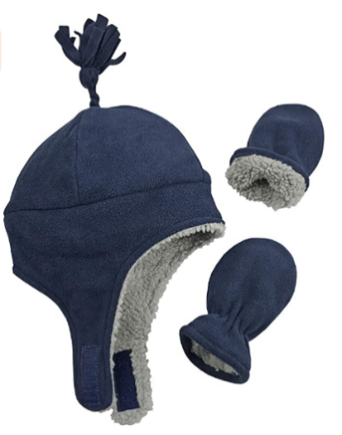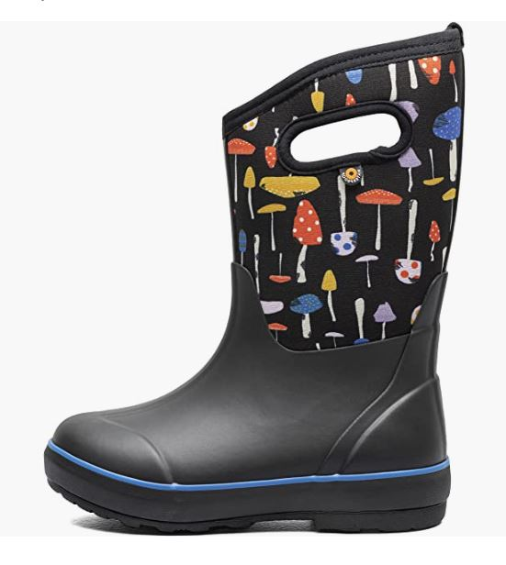

- Warm hat that covers the ears. Your child’s hat is one of the most important pieces of their kit. Check for comfort (well-fitting, not itchy, no scratchy tag) so that your child will keep it on their head. Fleece-lined hats that close under the chin are a great choice—cut long strings so they don’t pose a strangulation hazard during activity. Hoods can be added over hats, not in place of.
- Mittens. Mittens keep the hands warmer than gloves. The type of thin cheap gloves sold at dollar stores are not sufficient for warmth. Waterproof mitten shells over a pair of good gloves is an ideal combo. Don’t forget to label hats and mittens!!
- Socks and water-resistant shoes. Footwear is extremely important. Your child will be running around more than usual and kids don’t often notice when they’re getting blisters. Fit is very important to keeping feet warm and comfortable—too much space inside and feet get cold; too tight and feet have low circulation (and this also causes feet to get cold). Check the fit of boots with the socks you plan for your child to wear—their winter socks can be bulky!
Keeping feet dry helps prevent several kinds of foot issues. Rain boots are the best choice for most weather—there are year-round wet areas in our outdoor space.
When you get home with wet boots, blot them dry with a towel, pull out the insoles and hang them up or pop them in the dryer, then stuff the boots with loose wads of newspaper. Change the newspaper after 2-3 hours or prop the boots in front of a fan to finish drying. Optionally, you can buy two pairs of boots to rotate, or look for quick-drying boots when shopping. Clothes dryers will shorten the life of most rainboots.
Wool socks are worth the investment because they provide the best protection for feet and will keep feet warm even when wet. Look for the highest percentage of wool on the label and at least a midweight (or medium cushion) for the most durability. A couple of good quality options:
Smartwool socks
Darn Tough socks
Generic wool blend socks

- Extra socks packed--ALWAYS. At least one pair, packed in a sturdy ziplock or another waterproof bag.

Additions for hot weather –Sun hat, sunglasses, sunscreen
- Wide-brimmed sun hat. Sunday Afternoon and i play are two brands that make comfortable boonie hats for children with cords to secure them on your child’s head—invaluable in breezy conditions. A wide-brimmed hat gives better protection to the ears and neck than a baseball cap.
- If desired, sunglasses with UVA/UVB protection.
- Sunscreen on exposed skin. Please apply sunscreen before dropping off your child. During times of mosquito activity, you may apply your preferred insect repellent as well.
- Please remember to stick with closed-toed shoes. Sandals that protect the toes, like Keens, are OK.
Additions for very cold weather
- Increase insulation for the feet with thicker socks, or switch to insulated winter boots (Insulated boots are required for fall and winter quarters; optional for spring quarter).
- A jacket with an adjustable hood, a scarf or a neck warmer will help seal out drafts around the neckline. Scarves and neck warmers add protection for the face and keep little noses toasty. (A scarf is required for fall and winter quarters).
- Pack an extra fleece in their backpack.

Outfit Examples
Example 1: A chilly, partly cloudy day
Wear: A thin synthetic shirt, a sweater, a warm pair of sweatpants, rain paints, thick socks and rainboots
Pack: Warm hat, mittens, fleece jacket, raincoat, baseball cap, extra socks
_____________________________________________________________________________________
Example 2: A rainy, cold day
Wear: A thin synthetic shirt, a sweater, rain jacket, a warm pair of sweatpants, rain pants, baseball cap, thick socks and rain boots
Pack: Warm hat, mittens, waterproof mitten covers, fleece jacket, extra socks
_____________________________________________________________________________________
Example 3: A very cold day (Note that cold weather calls for multiple mid-layers!)
Wear: One or two thin synthetic shirts, a sweater, a fleece jacket, a rain jacket, a pair or two of leggings, a warm pair of sweatpants, rain pants, thick socks, winter boots, a warm hat, mittens and/or gloves
Pack: An extra fleece or jacket, a neck warmer, extra socks
_____________________________________________________________________________________
Example 4: A warm, partly cloudy day
Wear: A thin long/short-sleeved shirt, a pair of shorts or leggings, socks and rain boots (or sandals), sunscreen
Pack: A fleece jacket, rain coat, rain pants, a wide-brimmed sun hat, extra socks

Full Shopping List (Don’t forget to “shop” your child’s closet!)
□ Backpack
□ Leakproof water Bottle
□ Bandana
□ Lunch box if desired
□ Personal items: hand sanitizer, chapstick, *sunscreen (apply before school)*
□ Waterproof bag and Ziplock bags
□ Rain boots, well-fitting and without leaks
□ Rain suit or rain coat
□ Rain pants
□ Base layer shirt and leggings/pants (synthetic)
□ Mid-layer shirt and pants (synthetic)
□ Warm hat
□ Wide-brimmed sunhat
□ Mittens or gloves

For fall and winter, waterproof outer layers MUST be waterproof. Fall and winter students add:
□ Insulated boots
□ Scarf or neck warmer
□ Wool socks

Optional:
- Extras: Particularly, an extra pair of boots to rotate, extra socks, extra mittens, and an extra fleece. In fall/winter, one of my favorite tricks is to get an extra set of base layers and wear them both together.
- A thermos for a hot drink
- Field notebook (I recommend an unlined, hard cover, small to medium size notebook), writing utensils, a pencil case
- A baseball cap for wearing in the rain
- Closed-toed sandals
- Waterproof rain mittens
- Sunglasses

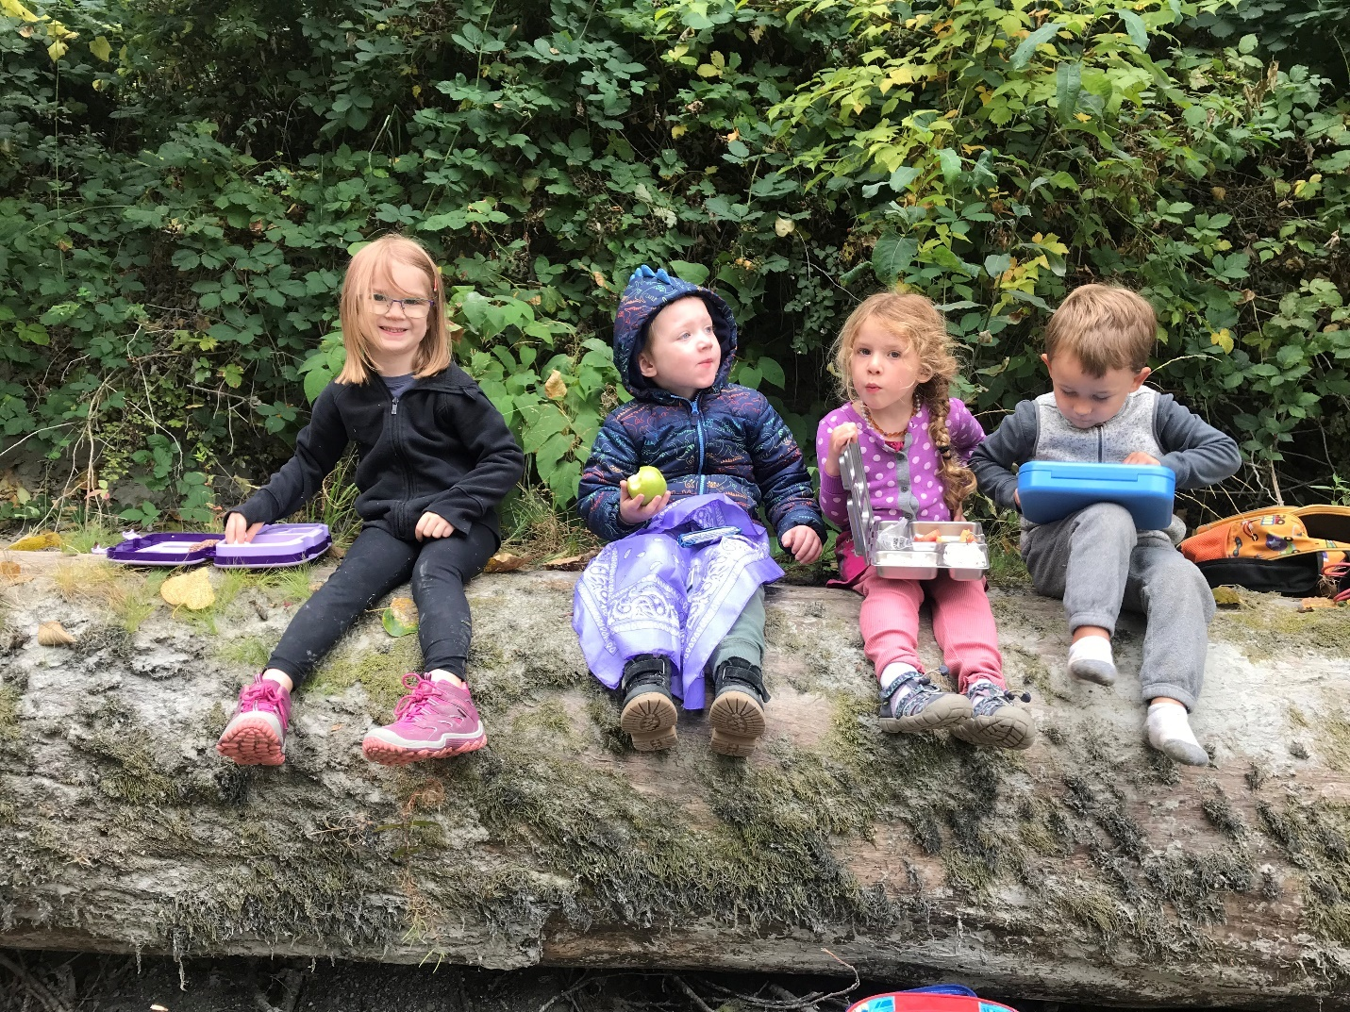

Your Child’s Transition to Outdoor Preschool

This is an exciting time for you and your child as they begin to learn new skills and make new friends. There are a few things you can do to help prepare your child for the transition into school.
Please talk with your child about their new school. Talk about all the new things they will be doing. Tell them their new teacher is excited about them coming to her class.

Make sure your child gets a good night’s sleep before attending school. Tired children do not respond well to the activities or benefit from the instruction provided.

Make things easy on yourself and do everything you can the night before: Set out clothes, pack their bag, assemble their snack, fill their water bottle.
Meeting new people and leaving mom and dad may cause your child to be reluctant about coming. Even kids who have been very excited for school may feel ambivalent about leaving Mom or Dad to start the school day. Be willing to listen to their feelings and don’t try to talk them out of them. Giving kids plenty of time to make the transition is vital, so plan to arrive early, especially during the first few weeks.

If you’re apprehensive about how your child will handle being out in the cold or the rain, don’t show it! They take their cues from you. If you’re calm and positive about it, you’ll be surprised how easily your child accepts the weather. Dressed properly, they will be fine!

Dress yourself for the weather so that you aren’t shivering or hurrying to complete drop off. When you arrive at our outdoor classroom reassure your child that they will have fun and tell them you will return “before we have lunch with Grandma” or “after your hike with your friends.”

Expect your child to be wet, dirty, or muddy at pick up. Be ready to protect your car and get them into clean, dry clothes and shoes if you won’t be home right away.
Your child may be more tired than normal due to the higher activity level, and you might want to consider putting him in bed earlier for a couple of weeks. You’ll also want to keep an eye on his feet, especially if his shoes are new. Look for any blisters and make sure shoes are dry before the next wearing.

As with all transitions, there may be a settling-in period as he gets used to the new routine. Most kids love school as soon as they settle in. Please talk to your child’s teacher if you have any concerns. We can’t wait to welcome your new preschooler!

Safety at Chickadee Hollow Outdoor Preschool
Safety is our top priority at Chickadee Hollow Outdoor Preschool.
Supervision
One of the most important things we do to keep kids safe is to keep our teacher to child ratios low. We at Chickadee Hollow Outdoor Preschool believe we can offer a higher quality education by increasing the attention available from our teachers. We staff at least one teacher for every four students, primarily to enhance learning through lots of individual attention. Ample staffing is also the first measure of child safety: Many pairs of adult eyes and hands trained in ACTIVE supervision, meaning kids must remain in teacher’s visual and auditory supervision at all times for instant adult response.
Parent/caregiver identification
Pre-approved photo identification is required for every person picking up your child. Persons not familiar to the teacher will be asked for photo ID upon pick-up.
Safety Equipment
All teachers are trained in first aid and child CPR. In addition to bringing all the first aid and sanitization equipment for typical child care use, our teachers bring emergency equipment to deal with the special situations of an outdoor environment onsite each day, including a cell phone with emergency solar charger, emergency blankets and emergency body warmers, extra water, extra sunscreen, instant ice packs, blister and chafing treatments, energy gels for prevention of shock, treatment for insect stings, tweezers, eye wash equipment, toileting and trash containers, etc.
We are fortunate to have several options for shelters at our location, as well as tree cover for lighter rain conditions and shade. In addition, our teachers utilize activities to harmonize with environmental conditions, i.e., on a cold morning, teachers will begin the day by encouraging games involving movement like squats because warming up the quadriceps, the largest muscles in the body, creates substantial amounts of heat in the body.
Parents are responsible for outfitting their children with clothing appropriate for current weather conditions. We cannot sign in your child for the day if his/her clothing is inadequate for expected weather: this is a safety concern! For additional details on what to bring each day, please consult the included handout: Daily Items.
Emergency evacuation
There are several procedures for relocating our class in the unlikely event of any situation that makes teachers uncomfortable about safety: In any situation representing possible danger, police will be contacted. In addition to contacting the police, depending on the situation, teachers may quietly gather students for a “surprise hike,” an evacuation technique modeled on those of other outdoor preschools operating in public spaces. We will not leave the Haller Park premises unless it is necessary. We will notify parents via text and/or phone call if we evacuate from the Haller Park premises and leave a note if possible. Our designated emergency evacuation meeting spot is the parking lot at Grocery Outlet. Arlington police have the authority to immediately remove any individual from a public park whose behavior presents a concern and we have worked with Arlington police to develop our policies for teacher training and evacuation. Arlington police are committed to maintaining a presence at the Haller Park parking lot as much as available resources allow, as a deterrent from criminal activity in the vicinity. We have also collaborated with the maintenance department of Arlington parks to coordinate their park maintenance schedules with our class times so that staff will be present in the Stormwater Wetland Park as much as possible while we’re having classes. As of 2023, the city of Arlington is moving forward with several measures to discourage criminal uses of public property including drug use and illegal camping. Undergrowth has been removed in the Stormwater Wetland Park area where camping has been a problem in the past, and the boarded-up building is scheduled for removal. A camera will be replaced in that area following the demolition, and there is a camera pointed at Haller Park that is monitored 24/7 and actively used to discourage people from camping in the area. Ultimately there are always risks involved with being in public places and it is the parent’s responsibility to evaluate the risks and benefits of enrollment.
Risk
It’s important for children to explore healthy risk-taking and discover their own limits with their bodies. As their teachers, we try not to get in the way of that process when the outcomes of miscalculation are minor (falling from a low branch and getting a bruise or scrape). Bruises and scrapes are usually a sign your kids have been having fun and have experienced a wonderful opportunity to learn body awareness.
We do not experiment with fire, knives, or sharp tools. We encourage you to explore these things with your kids as a family. Please do not allow your child to bring pocketknives or similar items to school. Sticks and rocks are one of the best parts of playing outside but throwing rocks is limited to beach and water settings and we will set limits for your child if necessary to ensure their safety.
The River
We are lucky to have forest, meadow, and marsh habitats to explore a diverse range of plants, animals, and geographic features, all within a few minutes’ walk of our drop-off shelter. Also within a few minutes’ walk is the Stillaguamish river, providing rocky beaches, opportunities to sight eagles, herons, deer, and beavers, and offering an entry point for conversations on local and regional history including early logging, Native uses of the river, and so much more.
However, the river itself is out-of-bounds to our students at all times, and no child will be permitted to enter the river while at school. We also encourage parents to be vigilant in the parking lot, because the boat launch is easily accessible by small children. People are often surprised by how much the river can change throughout the course of the year, and the shallow, slow water of July can be a hazardous torrent in the same spot in November. We love to play near the creeks, wetland cells, and tidepools on the beach. Any water in our outdoor space higher than a child’s ankles, including puddles, is off limits.
Note: Flood warnings are common during the winter season but unlikely to affect the use of our area of the park or of the parking lot.
Dog Park
The shelter we use for drop-off and many school activities is located next to an enclosed dog park. There are often dog owners visiting the area. Please remind and practice with your children to always ASK before petting someone’s dog. Dog bites can be serious.

September | 2023
Monday | Tuesday | Wednesday | Thursday | Friday | Saturday | Sunday
 |  |  |  | 1 | 2 | 3
4 | 5 | 6 | 7 | 8 | 9 | 10
11 | 12 | 13 | 14 | 15 | 16 | 17
18 | 19 | 20 | 21 | 22 | 23 | 24
 | 9:00am Preschool |  | 9:00am Preschool
25 | 26 | 27 | 28 | 29 | 30
 | 9:00am Preschool |  | 9:00am Preschool

October | 2023
Monday | Tuesday | Wednesday | Thursday | Friday | Saturday | Sunday
 |  |  |  |  |  | 1
2 | 3 | 4 | 5 | 6 | 7 | 8
 | 9:00am Preschool |  | 9:00am Preschool
9 | 10 | 11 | 12 | 13 | 14 | 15
 | 9:00am Preschool |  | 9:00am Preschool
16 | 17 | 18 | 19 | 20 | 21 | 22
 | 9:00am Preschool |  | 9:00am Preschool
23 | 24 | 25 | 26 | 27 | 28 | 29
 | 9:00am Preschool |  | 9:00am Preschool
30 | 31
 | 9:00am Preschool

November | 2023
Monday | Tuesday | Wednesday | Thursday | Friday | Saturday | Sunday
 |  | 1 | 2 | 3 | 4 | 5
 |  |  | 9:00am Preschool
6 | 7 | 8 | 9 | 10 | 11 | 12
 | 9:00am Preschool |  | 9:00am Preschool
13 | 14 | 15 | 16 | 17 | 18 | 19
 | 9:00am Preschool |  | 9:00am Preschool
20 | 21 | 22 | 23 | 24 | 25 | 26
 | Thanksgiving break |  | Thanksgiving break
27 | 28 | 29 | 30
 | 9:00am Preschool |  | 9:00am Preschool

December | 2023
Monday | Tuesday | Wednesday | Thursday | Friday | Saturday | Sunday
 |  |  |  | 1 | 2 | 3
4 | 5 | 6 | 7 | 8 | 9 | 10
 | 9:00am Preschool |  | 9:00am Preschool
11 | 12 | 13 | 14 | 15 | 16 | 17
 | 9:00am Preschool |  | 9:00am Preschool
18 | 19 | 20 | 21 | 22 | 23 | 24
 | Winter break |  | Winter break
25 | 26 | 27 | 28 | 29 | 30 | 31
 | Winter break |  | Winter break

January | 2024
Monday | Tuesday | Wednesday | Thursday | Friday | Saturday | Sunday
1 | 2 | 3 | 4 | 5 | 6 | 7
 | Winter break |  | Winter break
8 | 9 | 10 | 11 | 12 | 13 | 14
 | 9:00am Preschool |  | 9:00am Preschool
15 | 16 | 17 | 18 | 19 | 20 | 21
 | 9:00am Preschool |  | 9:00am Preschool
22 | 23 | 24 | 25 | 26 | 27 | 28
 | 9:00am Preschool |  | 9:00am Preschool
29 | 30 | 31
 | 9:00am Preschool

February | 2024
Monday | Tuesday | Wednesday | Thursday | Friday | Saturday | Sunday
 |  |  | 1 | 2 | 3 | 4
 |  |  | 9:00am Preschool
5 | 6 | 7 | 8 | 9 | 10 | 11
 | 9:00am Preschool |  | 9:00am Preschool
12 | 13 | 14 | 15 | 16 | 17 | 18
 | 9:00am Preschool |  | 9:00am Preschool
19 | 20 | 21 | 22 | 23 | 24 | 25
 | 9:00am Preschool |  | 9:00am Preschool
26 | 27 | 28 | 29
 | 9:00am Preschool |  | 9:00am Preschool

March | 2024
Monday | Tuesday | Wednesday | Thursday | Friday | Saturday | Sunday
 |  |  |  | 1 | 2 | 3
4 | 5 | 6 | 7 | 8 | 9 | 10
 | 9:00am Preschool |  | 9:00am Preschool
11 | 12 | 13 | 14 | 15 | 16 | 17
 | 9:00am Preschool |  | 9:00am Preschool
18 | 19 | 20 | 21 | 22 | 23 | 24
 | 9:00am Preschool |  | 9:00am Preschool
25 | 26 | 27 | 28 | 29 | 30 | 31
 | 9:00am Preschool |  | 9:00am Preschool

April | 2024
Monday | Tuesday | Wednesday | Thursday | Friday | Saturday | Sunday
1 | 2 | 3 | 4 | 5 | 6 | 7
 | Spring Break |  | Spring Break
8 | 9 | 10 | 11 | 12 | 13 | 14
 | 9:00am Preschool |  | 9:00am Preschool
15 | 16 | 17 | 18 | 19 | 20 | 21
 | 9:00am Preschool |  | 9:00am Preschool
22 | 23 | 24 | 25 | 26 | 27 | 28
 | 9:00am Preschool |  | 9:00am Preschool
29 | 30
 | 9:00am Preschool

May | 2024
Monday | Tuesday | Wednesday | Thursday | Friday | Saturday | Sunday
 |  | 1 | 2 | 3 | 4 | 5
 |  |  | 9:00am Preschool
6 | 7 | 8 | 9 | 10 | 11 | 12
 | 9:00am Preschool |  | 9:00am Preschool
13 | 14 | 15 | 16 | 17 | 18 | 19
 | 9:00am Preschool |  | 9:00am Preschool
20 | 21 | 22 | 23 | 24 | 25 | 26
 | 9:00am Preschool |  | 9:00am Preschool
27 | 28 | 29 | 30 | 31
 | 9:00am Preschool |  | 9:00am Preschool

June | 2023
Monday | Tuesday | Wednesday | Thursday | Friday | Saturday | Sunday
 |  |  |  |  | 1 | 2
3 | 4 | 5 | 6 | 7 | 8 | 9
 | 9:00am Preschool |  | 9:00am Preschool
10 | 11 | 12 | 13 | 14 | 15 | 16
 | 9:00am Preschool |  | 9:00am Preschool
17 | 18 | 19 | 20 | 21 | 22 | 23
 | 9:00am Preschool |  | 9:00am Preschool  Celebration!
24 | 25 | 26 | 27 | 28 | 29 | 30

